October 2020 – October 2025

|  |  |
| --- | --- |
|  | **2020-2025**  Source Water Protection Plan for **Bayview, Idaho** **PWS# ID1280014** |



**REVIEW AND UPDATE ANNUALLY\***

|  |  |  |
| --- | --- | --- |
| **Date Reviewed** | **Reviewed By** | **Comments**  **(Attach Additional Document as Needed)** |
| **Dec 2020** |  |  |
| **June 2021** |  |  |
| **Dec 2021** |  |  |
| **June 2022** |  |  |
| **Dec 2022** |  |  |
| **June 2023** |  |  |
| **Dec 2023** |  |  |
| **June 2024** |  |  |
| **Dec 2024** |  |  |
| **Oct 2025** |  |  |

Table of Contents

EXECUTIVE SUMMARY v

ACKNOWLEDGEMENTS viii

1 INTRODUCTION 1

1.1 Drinking Water System 1

2 SOURCE WATER PROTECTION STEPS 2

3 COMMUNITY PLANNING TEAM 3

3.1 Duties of the Planning Team 3

3.2 Mission Statement: 4

3.3 Vision Statement: 4

3.4 The Goals: 4

4 SOURCE WATER PROTECTION AREA DELINEATION 5

5 IDENTIFYING POTENTIAL SOURCES OF GROUND WATER CONTAMINATION 9

5.1 Point Sources 9

5.2 Nonpoint Sources 10

6 MANAGEMENT PLAN FOR SOURCE WATER PROTECTION MEASURES AND ACTIVITIES 11

6.1 Best Management Practices (BMPs) for Protecting Source Water 11

• * The Recertification Deadline was moved from 12/31/2024 to 10/31/2025 due to the delay of SWPP data gathering in 2020 that was caused by the 2020 Covid-19 pandemic. 22

7 EMERGENCY RESPONSE PLAN 23

8 PLANNING FOR NEW WATER SOURCES OR WATER SYSTEM IMPROVEMENTS 24

9 PUBLIC PARTICIPATION 27

10 REFERENCES 28

References 28

11 RESOURCES 28

12 GLOSSARY 29

Appendix A. 33

Potential Contaminant Source Inventory 33

Appendix B. 37

Best Management Practices (BMPs) to Protect Source Water 37

Literature for Public Awareness and Education 37

Appendix C. 43

Susceptibility Scores 43

System Construction Score: 47

Potential Contaminant Inventory/Land Use: 49

Appendix D. 51

Overview of Potential Contaminant Sources 51

Appendix E. 59

Source Water Protection – Certification Checklist 59

Source Water Protection Plan - Certification Checklist 61

List of Tables

Table 1. Bayview well information for wells #7 and #8 2

Table 2. Planning Team 3

Table 3. Protection measures and activities for 2021 – 2025 13

Table 4. Bayview PCI for Well #7 34

Table 5. Bayview PCI for Well #8 35

Table 6. Voluntary Best Management Practices to Protect Source Water 39

Table 7. Overview of Potential Contaminant Sources 53

List of Figures

Figure 1. Bayview well #7 delineation area 6

Figure 2. Bayview well #8 delineation area not exposed to Potential Contamination 7

Figure 3. Farragut Reservoir Tank (225,000 gal)-July 2019 24

Figure 4. Pend Oreille Pines Tank (100,000 gal) 25

Figure 5. Dromore Reservoir 25

Figure 6. Cape Horn Estates Reservoir 26

EXECUTIVE SUMMARY

Ground water and surface water, life-sustaining resources for the world’s population, are increasingly under threat of contamination. Regardless of how “pristine” or remote a community’s drinking water source may be, the only way to ensure good water quality and its adequate quantity for future generations is to implement measures now to protect this valuable resource.

Under the Safe Drinking Water Act Amendments of 1996, the State of Idaho Department of Environmental Quality (DEQ) is required by the United States Environmental Protection Agency (EPA) to assess every source of public drinking water for its relative sensitivity to contaminants regulated by the Act.

This assessment delineates the area from which the town of Bayview draws its water, identifies the potential contaminants within that area, and determines how susceptible it is to become contaminated. This susceptibility is based on 1) construction of the two wells; 2) land use characteristics above the aquifer and potentially significant contaminant sources; and finally 3) the hydrologic and geologic conditions surrounding the wells.

The Rathdrum Prairie Aquifer is the principal source for public drinking water for approximately 500,000 people in Kootenai County, Idaho and Spokane County, Washington. The Rathdrum Prairie Aquifer originates at the southern end of Lake Pend Oreille in Bonner County, Idaho and extends west under the Rathdrum Prairie in Idaho and the Spokane Valley in Washington, underlying approximately 370 square miles of land. Because the aquifer is the principal source of public drinking water available for this region, the United States Environmental Protection Agency designated the Rathdrum Prairie Aquifer as a sole source aquifer in 1978. It was the second aquifer in the nation to receive sole source designation. In 1980, the Rathdrum Prairie Aquifer was also designated as a Special Resource Water. Because of its status, the Rathdrum Prairie Aquifer became the only aquifer in Idaho to be classified in the Sensitive Resource category when the state Ground Water Quality Rule was promulgated. Through Idaho’s sensitive resource designation, standards stricter than those outlined in Idaho Department of Environmental Quality’s Ground Water Quality Rule can be applied to this aquifer.

In 2007, the Aquifer Protection District was established in Kootenai County, Idaho by the state legislature. The purpose of the Aquifer Protection District is to protect groundwater quality by assisting regulatory bodies with enforcement of existing regulations, monitor and inspect potential sources of pollution and coordinate the work of public agencies to assist in the prevention of degradation of our valuable ground water and to avoid the extensive cost of remedial action. The Aquifer Protection District is also instrumental in implementing educational programs for the entire community that enhances protection of the public drinking water sources.

Bayview W&S District participates in source water protection efforts including groups such as:

* Kootenai County Aquifer Protection District
* Idaho Rural Water Association (IRWA) conferences and IDEQ educational workshops

The town of Bayview has utilized the information provided in the water system’s Source Water Assessment (SWA) to develop and implement a variety of non-regulatory protection measures and activities designed to help educate the public on the need to protect the land area within the delineation area of the two separate wells that serve the water users of Bayview, Idaho.

This document intends to account for the town of Bayview protection efforts and present a schedule for implementing measures over the next five (5) years. Bayview Public Water System intends on keeping its source water protection plan (SWPP) updated and certified by the State of Idaho. This protection plan includes the following:

* The description of the Bayview Water & Sewer District drinking water system;
* The development of the source water protection planning team and its duties;
* The analytical delineations of the areas from which the city draws drinking water from the Rathdrum Prairie Aquifer;
* Inventory and priority rankings of point and nonpoint contaminant sources within each of the delineated source water assessment areas;
* An implementation schedule for source water protection measures and activities;
* Coordinate with Farragut State Park Water System on SWP procedures;
* A separate Emergency Response Plan that will provide guidance and direction, should a drinking water emergency arise.

One aspect of such a project cannot be stressed enough, that of **implementation and follow-through**. Regardless of how thoughtful and far-reaching protection measures may be, implementation and follow-through are critical to achieving success. Community drinking water systems throughout the state must be diligent in their protection efforts in order to meet the growing demands of population growth, encroachment due to community development, and the added threats of contamination. The most important steps that the city can take to help in protecting the contributing watershed area includes the following:

1. Take immediate action to reduce the potential of contamination by all sources of potential contaminants that may include fertilizer and pesticides, and turbidity resulting from surface water runoff or soil disturbance.
2. Participate in promoting public awareness and education of watersheds and their contributing role in ground water and surface water protection. Because Bayview is located on the Rathdrum Prairie Aquifer, multiple state and federal agencies and other entities are involved in the decisions of land use and management within the watershed area the aquifer encompasses. It would be in the best interest for the city to coordinate with local landowners, federal, state or local agencies or commissions whose land use decisions may result in an increased risk to the quality of the Rathdrum Prairie Aquifer. Risks to consider may include but are not limited to the following:

* Private, state and federal land timber harvesting and mineral extraction mining (IOCs, VOCs, sediments)
* Urban development and pollutants associated with storm water runoff and transportation corridors (IOCs, SOCs, VOCs, sediments)
* Agricultural activities (IOCs, SOCs, VOCs, microbials and sediments);
* Private waste systems (microbes)

1. Develop and provide public awareness and education materials to the system’s water users, any local neighborhood associations, neighboring developments, and local businesses. This may include but is not limited to information relating to the following:

* Source water protection and how watersheds contribute to the welfare and livelihood of the Rathdrum Prairie Aquifer and neighboring communities
* Proper use and disposal of household hazardous waste (HHW) and landscape and gardening fertilizers and pesticides
* Best management practices (BMP’s) for construction/development.
* Prevention of accidental backflow or cross connection occurrences
* Water conservation.

This source water protection plan is a **“living document”** and should be reviewed and updated on a regular basis (annually) to reflect what protection measures have been achieved and what will be accomplished in the future.

ACKNOWLEDGEMENTS

The Community Planning Team extends its gratitude to the drinking water system employees who are the “front line” professionals that play a vital role in all aspects of the drinking water utility. Their efforts and expertise in source water protection is tremendously valuable and critical to success.

In addition, IDEQ would like to express a special thanks to Robert Kuchenski (Water Operator and Source Water Protection Team Leader) and the other members of the team for their help in organizing this Source Water Protection Plan and the accompanying Emergency Response Plan. These plans were constructed through meetings and data collection over the past 18 month. The SWPP and ERP will be in effect through October 2025. At that time, Bayview Water & Sewer will work with Idaho DEQ on recertification of the two plans to be in active for five more years.

*This page intentionally left blank for correct double-sided printing*

# INTRODUCTION

Source water protection[1], is a voluntary program in the State of Idaho implemented at the local level. Bayview has developed a source water protection plan to identify and outline steps to help prevent contamination of the ground water source that supplies Bayview’s public water system with drinking water. The Rathdrum Prairie Spokane Valley (RPSV) Aquifer provides drinking water for Bayview and surrounding cities and unincorporated areas in Idaho and Washington (Coeur d’Alene, Post Falls, Hayden, Hayden Lake, and Rathdrum, in Idaho and Spokane and Spokane Valley in Washington). The RPSV is a designated sole source aquifer and protection of this resource is critical to the health and welfare of the community. Measures directed toward source water protection will help protect this resource from ground water contamination by monitoring land use that occurs within the areas overlying the aquifer.

Many materials such as pesticides, fertilizers, organic chemicals, and human and animal wastes can contaminate ground water and surface water. The degree of contamination depends on many factors including soil characteristics, the volume of contaminant and its properties, climate and ground water or surface water flow. Once ground water or surface water becomes contaminated, it is often difficult and expensive to remediate. A community public water system with a contaminated source water supply will probably be required to do additional monitoring and may need to install water treatment equipment, or find a new source of drinking water. The most cost-effective approach is to prevent contamination before it occurs, rather than attempting to remedy contamination problems after they have occurred.

## Drinking Water System

The Bayview Water System is located on the Rathdrum Prairie Aquifer in Kootenai County, Idaho. The water system consists of two wells #7 and #8 (well information in Table 1 on page 2) that supply water in a lead / lag alternating pattern. Each well is located inside a pump house. Each well can produce 700 to 800 gallons/min. Both wells also have flow to waste capability and meet all current set back requirements. **Chlorine disinfection is provided at the Cape Horn Booster Station** due to some historical coliform bacteria problems.

Bayview Water & Sewer District owns and maintains **four storage reservoirs**.

1. #1 is the **Farragut** Reservoir that holds 225,000 gallons of water for Bayview residents.

2) #2 is the **Dromore** Reservoir that holds 11,000 gallons for Dromore subdivision.

3) #3 is the **Pend Oreille Pines** Reservoir that holds 100,000 gallons for Pend Oreille Pines.

4) #4 is the **Cape Horn Estates** Reservoir consisting of two 30,000 gallon tanks.

Table . Bayview well information for wells #7 and #8

|  |  |  |  |  |  |  |  |  |  |
| --- | --- | --- | --- | --- | --- | --- | --- | --- | --- |
|  | **Well Depth bls/** | **Static Water Level** | **Casing: diameter/** | **Casing: depth (ft)/ formation** | **Perferations** | **Surface Seal:** | **Drill** | **Sanitary** | **Pump Rate Capability** |
| **Surface Elev. amsl** | **(ft)** | **thickness (in)** | **(ft)** | **depth (ft)/** | **Year** | **Survey** | **(gpm)** |
| **(ft)** |  |  |  | **formation** |  |  |  |
| **Well #7** | 331 | 225 | 18/0.875 | 320 | 20 per 67 ft | 25  Sand & Gravel | 1942 | 3/26/2019 | 750 |
|
| **Well #8** | 331 | 225 | 18/0.875 | 320 | 20 per 67 ft | 25  Sand & Gravel | 1942 | 3/26/2019 | (750-800) |
|  |  |

# SOURCE WATER PROTECTION STEPS

The Bayview Water and Sewer System has prepared this source water protection plan (SWPP) in accordance with the five-step process for source water protection outlined in Protecting Drinking Water Sources in Idaho (DEQ 2000).

These five steps are:

Step 1: Formation of a community planning team.

Step 2: Delineation of the source water area (land area to be protected).

Step 3: Identify sources of contamination (point and nonpoint).

Step 4: Manage the source water area through implementation of regulatory and/or non-regulatory measures (management plan for source water protection measures and activities).

Step 5: Prepare for the future through the development of a contingency plan that will provide guidance and direction, should a drinking water emergency arise.

This (SWPP) was developed for a five year period. The period is (2020-2025) with technical assistance from the Idaho Department of Environmental Quality (DEQ).

# COMMUNITY PLANNING TEAM

The **first step** in the development of a protection plan consists of forming a planning team. The system’s planning team includes the following individuals listed in Table 2.

Table . Planning Team

|  |  |
| --- | --- |
| ***Athol Water and Sewer District*** | |
| Bob Kuchenski | Team Leader & Licensed Water Operator |
| Ali Spahn | Assistant Team Leader |
| Ted Bare | Planning Team Member |
| Jessie Roe | Administrative Assistant (Treasurer) |

Technical assistance was provided by:

|  |  |
| --- | --- |
| John Jose | DEQ Source Water Analyst (Cd’A office) |
| Anna Moody | DEQ Drinking Water Program Supervisor (Cd’A office) |
| Rachael Smith | DEQ state Office, Boise |
| Brady Johnson | DEQ state Office, Boise |
| Kathryn Elliott | DEQ state Office, Boise |
| Susan Beattie | DEQ state Office, Boise |
| Scott Miller | DEQ state Office, Boise |

## Duties of the Planning Team

Bob Kuchenski is chosen as the Team Leader and has the responsibility for the following:

* Planning and coordinating future team meetings

Coordinating and ensuring that the protection measures and activities identified in this document are implemented in Table 3 on page 13.

Bob Kuchenski will be the lead contact for any outside references to this Plan. As water system operator, Bob will also be the designated contact in case of a water system emergency, outlined in Bayview’s separate emergency response plan. Backup team members Ali Spahn and Ted Bare will share team responsibilities and attend all meetings and events. Idaho DEQ will continue to provide support and technical assistance to the planning team, regarding any of the protection plan’s stategic components.

The planning team should:

* Hold meetings every year to review the progress of Bayview’s source water protection measures developed and implemented thus far. Bayview’s emergency response plan is to be reviewed for accuracy as well. Meeting dates, locations and times are to be announced, posted, or otherwise advertised in accordance with the laws and regulations that govern public meeting requirements in Idaho.
* Update the contaminant source inventory annually, adding any new point or nonpoint sources of contamination identified in the delineated source water area (Appendix A).
* Evaluate and *prioritize* new and proposed contaminant sources within the delineated source water area for their risk to the water system.
* Coordinate implementation of the source water protection measures identified in the Management Plan to protect the community’s drinking water source and community residents and visitors.
* Use informational materials to implement public education and outreach activities in accordance with the management plan. Examples will be found in “Protecting Drinking Water Sources in Idaho (DEQ, 2000) or on-line at DEQ’s website, <http://www.deq.idaho.gov/water-quality/source-water/>
* Coordinate with the Bayview officials and/or Kootenai County Planning and Zoning and private landowners to promote best management practices (BMPs) designed to protect the Rathdrum Prairie Aquifer from which the District obtains drinking water.

## Mission Statement:

Bayview Water District’s mission is to provide affordable, reliable and safe water to our customers. To accomplish this mission, Source Water Protection will be an integral component.

## Vision Statement:

The Planning Team’s vision is to provide the Bayview Water District Customers a safe and reliable source of drinking water and fire protection at a reasonable cost now and in the future.

## The Goals:

Bayview Water System is aware that the mission, vision and goals meet every requirement of the AWWA G-300 Source Water Protection Standard for guiding the district’s SWPP.

**Goal #1**: Protect Bayview Water District’s source of drinking water from contamination.

**Goal #2:** Commit sufficient resources within budget limitations to ensure the water quality protection and the safety of the water sources.

**Goal #3**: Educate / Outreach Source Water Protection Techniques to all water users

**Goal #4:** Maintain the partnership with nearby public water system (Farragut State Park) to aid in the protection of the Bayview Water System Water Source

# SOURCE WATER PROTECTION AREA DELINEATION

The **second step** in the development of a SWPP requires **delineating the source water area** from which the Town of Bayview draws its drinking water. The delineation process, completed in the source water assessment (SWA), establishes the physical area around a well, from which ground water is drawn. The process includes mapping the boundaries of assessed source water area into *time-of-travel* (TOT) zones.

The 1996 amendments to the Safe Drinking Water Act require the state to assess every public water supply. In response to these requirements, DEQ developed the *Idaho Source Water Assessment Plan* (DEQ, 1999) that describes the major components of, and procedures for, conducting source water assessments. For ground water systems, the state plan provides that the assessed source water area be divided into fourTOT zones (IA, IB, II, and III). All zones are designed with the intention of preventing microbial or chemical contamination of a community’s drinking water supply:

* Zone IA is the sanitary setback zone designed to prevent microbial contamination within a 100-foot radius of a well, spring or surface water intake. This setback zone is established in the Idaho Rules for Drinking Water Systems (IDAPA §58.01.08.900.01) and requires:
  + sewer lines, livestock, canals, and streams be a minimum of 50 feet from the source water/wellhead
  + septic tanks, seepage pits, disposal fields, and privies a minimum of 100 feet away
* The (0 to 3) year TOT zone corresponds to SWPA Zone IB
* The (3 to 6) year TOT zone corresponds to SWPA Zone II
* The (6 to 10) year TOT zone corresponds to SWPA Zone III

The water system’s Source Water Assessment Final Report (August 16, 2016) for these wells provides a detailed description of the delineated source water area and is available at DEQ’s website: <http://www.deq.idaho.gov/water/swaOnline>

Figure 1 (page 6) provides the source water delineation area of Well #1

Figure 2 (page 7) provides the source water delineation are of Well #2

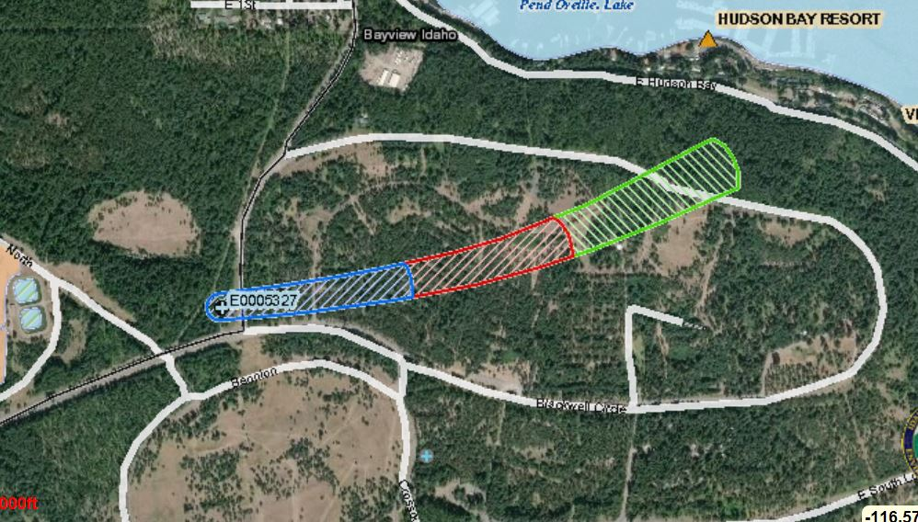

Figure . Bayview well #7 delineation area

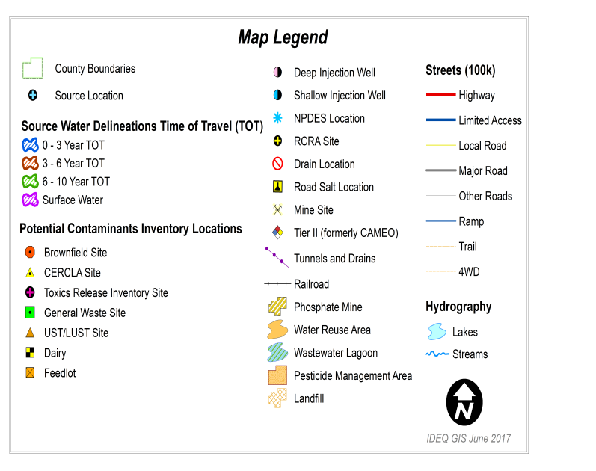

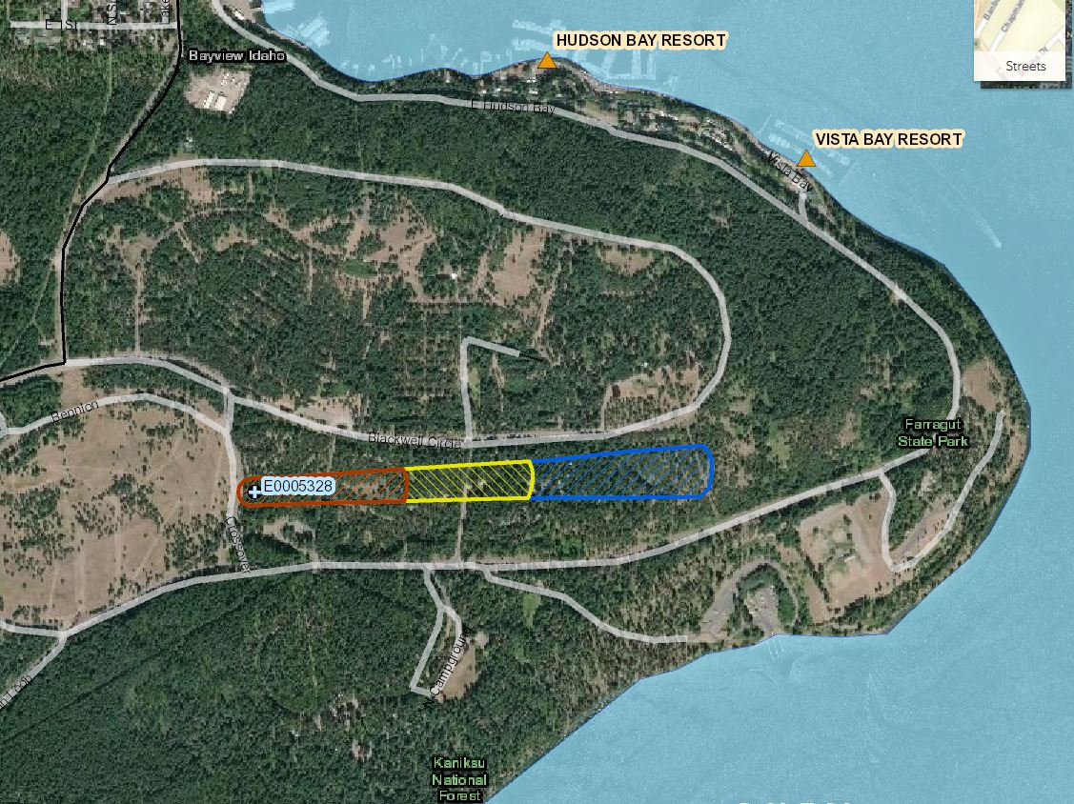

Figure . Bayview well #8 delineation area not exposed to Potential Contamination

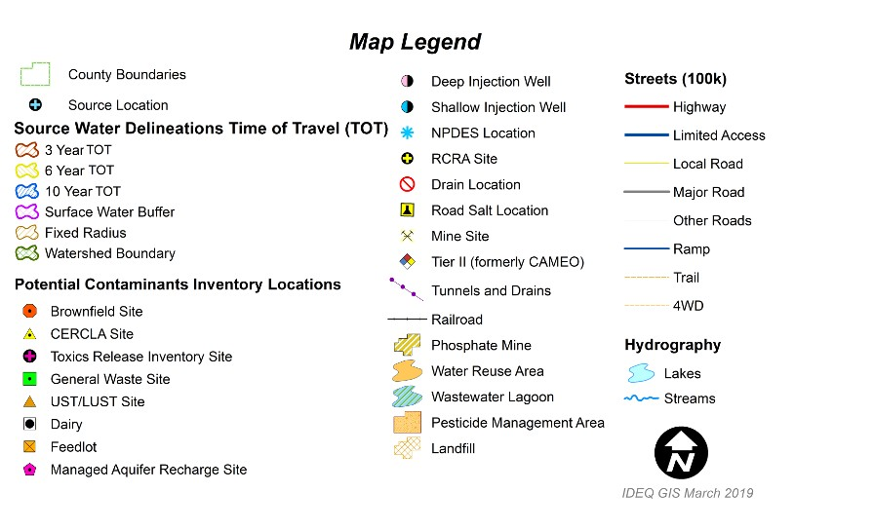

*This page intentionally left blank for correct double-sided printing*

# IDENTIFYING POTENTIAL SOURCES OF GROUND WATER CONTAMINATION

The **third step** is to identify potential sources of contamination that requires performing an inventory of contaminant sources within the assessed source water area. As part of the process, a two-phased potential contaminant source inventory of the study area was conducted.

The first phas**e** involved identifying and documenting contaminant sources within the source water areas (Figure 1 and Figure 2) using computer databases and Geographic Information System (GIS) maps developed by DEQ. These sources are included in Appendix A (page 33).

The second, or *enhanced phase* of the potential contaminant source inventory, involved requesting the licensed water operator to validate the contaminants identified in the first phase and to identify additional contaminant sources in the source water areas. This was accomplished by touring the assessed source water areas to search for and identify contaminants not identified previously. There were **no additional contaminant sources** identified at this time.

The planning team accomplished an additional step by prioritizing and ranking the identified sources as to each source’s known or perceived threat to the aquifer or watershed that serves as a drinking water source. This priority ranking is also included in Appendix A.

It is important to understand that a release may never occur from a listed source, particularly if the facility is using (BMPs) designed to reduce contamination risks. If a business, facility or property is identified as a potential contaminant source, this should not be interpreted to mean that they are in violation of any local, state, or federal environmental law or regulation. What it does mean is that the potential for contamination exists due to the nature of the business, industry or operation.

Potential sources of contamination for well #7 – Appendix A and Table 4-page 35 include the Major and Minor roads that act as potential sources of contamination.

Potential sources of contamination of well #8 – Appendix A and Table 5-page 36 show that the delineation area of Well #8 does not intersect any sources of potential contamination.

## Point Sources

Point sources of contamination occur at distinct locations. Point sources are facilities and/or activities that store, use, or produce potential contaminants regulated under the Safe Drinking Water Act. These sites are regulated and require permits or registration to sell, use or store the potentially contaminated materials.

Potential sources of contamination for **well #7** (Appendix A, Table 4): State Hwy 54 is the only Potential Contaminant that could affect well #7. Blackwell circle was originally thought to be a source, but is far from the well and out of the delineation area (See page 34).

Potential sources of contamination for **well #8** - **(No PCI conducted due to no potential sources of contamination in the zone of influence).**

The Bayview Water & Sewer District has negotiated a permanent easement (*September 2020*) that addresses the required 50 foot radius around the well to be free of possible contaminant, thus satisfying the 50 foot setback requirements for Well #8.

*The Delineation Area for Well #8 is all within the park with no current or future plans to add any new roads that would introduce sources of potential contamination.

## Nonpoint Sources

Nonpoint sources of contamination often occur over large areas and can result from normal every day activities such as agricultural activities or lawn chemical usage. There must be a potential for a release of those contaminants at a high enough level that could affect drinking water quality.

Land use within the immediate and surrounding area of Bayview’s Wells #7 & #8 include mostly rural residential uses with potential contamination from rural roadway runoff. Potential contamination resulting from any runoff and leaching of fertilizer/pesticide application can contribute to elevated levels of nitrogen and occurrence of synthetic organic chemicals in the ground water. By incorporating the best management practices (BMPs), such as applying the appropriate amount of fertilizer or other chemicals to the surface and promoting the prevention of runoff from the rural roadways can help reduce potential contamination risk to the ground water sources of drinking water.

It is vital that Bayview Water System remain committed to providing opportunities for public awareness and education. This outreach education to the public can be achieved by:

* Notices included in the monthly water bill
* Public service announcements (PSAs) and opportunities to provide additional information on local radio programming and postings on their web site and facebook
* Community events where source water protection information is available to the public
* Continued participation in regional committees and organizations…… (listed in the Executive Summary on page iv)

While development of a source water protection plan is a voluntary action in Idaho, drinking water systems are required to keep current with the Idaho Rules for Public Drinking Water Systems (IDAPA 58.01.08).

Therefore, Bayview Water System would have to correct any deficiencies and maintain requirements outlined in their most recent sanitary survey completed by DEQ (DEQ 2019).

However, there were no significant deficiencies related to source water issues at the time of the latest **Sanitary Survey that was conducted on March 26, 2019**.

# MANAGEMENT PLAN FOR SOURCE WATER PROTECTION MEASURES AND ACTIVITIES

The **fourth step** is the development of a management plan and implementation schedule for source water protection measures and activities. The strategy for implementing a protection plan is an important component of a source water protection program.

Without the continued efforts and support of the planning team and the community as a whole, the protection of the watershed that serves as drinking water sources for Bayview, may not be accomplished as intended within this plan.

In creating a sustainable source water protection program, the Bayview Source Water Protection Planning Team identified measures and activities specifically designed to help protect the water system’s two ground water wells by addressing the potential contaminant sources listed in the source water assessment (SWA) and those identified by the team. This management plan describes protection measures and activities over a five-year period.

## Best Management Practices (BMPs) for Protecting Source Water

BMPs are practices or combinations of practices that ultimately prevent or reduce contamination to groundwater and surface water. Although often associated with agricultural activities, BMPs can apply to any activity that has the potential to impact ground water or surface water.

Voluntary BMPs which ranchers, farmers and urban homeowners can take to help protect ground water and surface water sources on their property should be made available to those that are interested. If necessary, BMPs can be required through regulations that may further define what a BMP is and how it is to be applied. In the case of Bayview, the concentration is focused on protecting Wells #7 and #8 from runoff of salt and other contamination from roadway surfaces or any other source of excess pesticide or fertilizer.

Appendix B (page 37) provides examples of voluntary tools and BMPs developed to protect source water resources. The Source Water Protection Activity Guide is a resource developed by DEQ that presents activities to minimize potential threats to source water. The guide is available at: [**https://www.deq.idaho.gov/water-quality/source-water/activity-guide**](https://www.deq.idaho.gov/water-quality/source-water/activity-guide)***.***

Protection measures identified by the planning team are listed in Table 3 (page 13) that describes protection activities scheduled over a five year period starting 4th quarter 2020 and ending 4th quarter 2025.

**-REVIEW-**

**PUBLIC EDUCATION OUTREACH TOPICS**

1) Signs & information educating the public about the aquifer being their drinking water source…..(*Protect the drinking water source from contamination*)

2) Identify designated areas for pets-install pet waste stations

3) Fertilizers and Pesticides – (*a little is good- a lot is not)*

4) Storm water – Runoff draining to the lake or penetration to the aquifer

5) Dispose of pills and other drugs properly-Do not flush

6) Contamination that can seep into the aquifer (VOCs, SOCs & IOCs )-(*Don’t drain your oil on the ground because it can go directly to the aquifer)*

7) Backflow prevention- (*Home backflow examples have the potential to reach the source*)

8) Road Salt used on the roads during winter months can be a potential contaminant via runoff

**Review of goals set for Bayview’s Source Water Protection Plan:**

**Goal #1:** Protect Bayview Water District’s source of drinking water from contamination.

**Goal #2:** Commit sufficient resources within budget limitations to ensure the water quality protection and the safety of the water sources.

**Goal #3**: **Educate: Source Water Protection Techniques to all water users**

**Goal #4:** Maintain the partnership with nearby public water system (**Farragut State Park**) to aid in the protection of the Bayview Water System Water Source

# * The Recertification Deadline was moved from 12/31/2024 to 10/31/2025 due to the delay of SWPP data gathering in 2020, caused by the 2020 Covid-19 pandemic.

# * The plans will be State of Idaho Certified during the 4th quarter of 2020. However, the measures and activity plans will not start until 2021 to give the system time to organize its plan of SWP activities for 2021 and then continue plans for the following four years.

Table . Protection measures and activities for 2021 – 2025

| **Protection Measures and Activities** | **Date Completed** | **Responsible Party/Entity** | **Potential Contaminants Addressed** | **Specific Task(s)** | **Goal #** | **Public**  **Yes/No** |
| --- | --- | --- | --- | --- | --- | --- |
|  |  | **Year 1**  **2021** |  |  |  |  |
| Provide/Participate in educational activities/events -Educate Bayview water customers about source water protection | On going- Public Education  Initiate 4th quarter 2020 | Team Leader, Bob Kuchenski and Bayview’s SWP Planning Team | All Sources of Potential Contamination | SWPP information: Pamphlets, Monthly Newsletter, Website & Facebook Page | **#3** | Yes |
| Identify BMPs, Define Management Activities & Educational activities promoting Source Water Protection of Bayview’s drinking water source. Have SWP Information articles in some (not every) monthly newletter that are distributed to residents | Have in place by 3rd quarter 2021 | Bayview’s SWP Planning Team | All Sources of Potential Contamination | Management activities that identify BMPs that promote SWP through public Education of protecting Bayview’s drinking water sources | **#3** | No |
| Host a booth at the July 4th community celebrations | “July 4th days” | Bayview’s SWP Planning Team | Microbial, SOC, VOC, IOC | Public awareness & Education | **#3** | Yes |
| Encourage proper disposal of household hazardous wastes (HHW) and unused drug prescriptions | On going | Bayview’s SWP Planning Team | All Sources of Potential Contamination | Provide information to the Bayview residents regarding proper disposal | **#1,#3** | Yes |
| Encourage proper use and disposal of pesticides, fertilizer | On going | Bayview’s SWP Planning Team | All Sources of Potential Contamination | Provide reminders in Newsletter and on Website – (Pesticides & Fertilizer use) | **#1,#3** | Yes |
| Encourage proper backflow protection  (Garden Hoses etc) | On going | Bayview’s SWP Planning Team | All Sources of Potential Contamination | Make available backflow info on the website and monthly newsletter | **#1,#3** | Yes |
| Prepare for implementation activities for the year and update the current potential contaminate inventory (PCI) | To be updated on a regular basis | Bayview’s SWP Planning Team | All Sources of Potential Contamination | Hold annual SWPP meeting to discuss implementation schedule and assess any new businesses or sources of contamination in source water area. Update online PCI if needed. Invite the public | **#2** | Yes |
| Review and update Emergency Response Plan | Annual Review | Bayview’s SWPP Team | N/A | Review ERP & check all contact information for accuracy | **#1,#2** | No |
| Good Neighbor Policy | During summer months of 2021 | Bayview’s SWP Planning Team & public help | All Sources of Potential Contamination | addresses dog waste clean-up, water craft cleaning for purpose of not spreading aquatic noxious weeds, septic awareness | **#1, #3** | Yes |
| Septic Systems maintained by Bayview W&S | On going | Planning Team to educate public on septic use (what not to flush) | Individual septic systems drain to main systems | Distribute septic info via website & brochures | **#1** | Yes |
| Road salt (Ca&Mg) used on roads in winter. Team work to prevent run-off | Associate with Stormwater Education | SWP Planning Team and a community effort | Magnesium & Calcium Compounds | Work with ID. DOT to prevent runoff of salt from roads | #1 | Yes |
| Continue Storm Water Education- | Best to educate public during Summer Months | Bayview’s SWP Planning Team-  Work with Idaho DOT | Educate the public by addressing prevention of transporting contamination | Storm drain management – run off from roads and parking lots | **#1, #3** | Yes |
|  |  | **Year 2**  **2022** |  |  |  |  |
| Provide/Participate in educational activities/events -Educate Bayview water customers about source water protection | On going-Public Education | Team Leader, Bob Kuchenski and Bayview’s SWP Planning Team Team | All Sources of Potential Contamination | SWPP information: Pamphlets, Monthly Newsletter, Website & Facebook Page | **#2** | Yes |
| Identify BMPs, Define Management Activities & Educational activities promoting Source Water Protection of Bayview’s drinking water source. Have SWP Information articles in some (not every) monthly newletter that are distributed to residents | Have in place by 1st quarter of 2022 | Bob Kuchenski and Bayview’s SWP Planning Team | All Sources of Potential Contamination | Management activities that identify BMPs that promote SWP through public Education on protecting Bayview’s drinking water sources. | **#3** | Yes |
| Host annual booth at July 4th community event | July 4th celebrationdays 2022 | Bayview’s SWP Planning Team | Microbial, SOC, VOC, IOC | Public awareness & Education | **#3** | Yes |
| Encourage proper disposal of household hazardous wastes (HHW) and unused drug prescriptions | On going | Bob Kuchenski and Bayview’s SWP Planning Team | All Sources of Potential Contamination | Provide information to the Bayview residents regarding proper disposal | **#1 ,#3** | Yes |
| Encourage proper use and disposal of pesticides, fertilizer | On going | Bob Kuchenski and Bayview’s SWP Planning Team & Public | All Sources of Potential Contamination | Provide reminders in Newsletter and on Website – (Pesticides & Fertilizer use) | **#1 ,#3** | Yes |
| Encourage proper backflow protection | On going | Bayview’s SWP Planning Team with Public Assistance | All Sources of Potential Contamination | Make available backflow info on the website and monthly newsletter | **#1, #3** | Yes |
| Prepare for implementation activities for the year and update the current potential contaminate inventory (PCI) | To be updated 1st quarter of 2022 | Bayview’s SWP Planning Team | All Sources of Potential Contamination | Hold annual SWPP meeting to discuss implementation schedule and assess any new businesses or sources of contamination in source water area. Update online PCI may need adjusting. | #**1,**  **#2,**  **#3** | No |
| Good Neighbor Policy | During summer months of 2022 | Bayview’s SWP Planning Team with public help | All Sources of Potential Contamination | addresses dog waste clean-up, water craft cleaning for purpose of not spreading aquatic noxious weeds, septic awareness | **#1, #3** | Yes |
| Septic Systems maintained by Bayview W&S |  | Planning Team to educate public on septic use (what not to flush) | Individual septic systems drain to main systems | Distribute septic info via website & brochures | **#1** | Yes |
| Road salt (Ca&Mg) used on roads in winter. Team work to prevent run-off | Associate with Stormwater Education | Potential road salt can flow to the lake & affect aquifer | Magnesium & Calcium Compounds | Work with ID. DOT to prevent runoff of salt from roads | **#1** | Yes |
| Continue Storm Water Education- | Best to educate public during Summer Months | Bayview’s SWP Planning Team-  Work with Idaho DOT-Runoff Education | Educate the public by addressing prevention of transporting contamination | Storm drain management – run off from roads and parking lots | **#1, #3** | Yes |
| Review and update Emergency Response Plan | Annually | Bob Kuchenski and Bayview’s SWPP Team | N/A | Review ERP & check all contact information for accuracy | **#1,#2** | No |
|  |  | **Year 3**  **2023** |  |  |  |  |
| Provide/Participate in educational activities/events -Educate Bayview water customers about source water protection | On going | Bayview’s SWP Planning Team | All Sources of Potential Contamination | SWPP information: Pamphlets, Monthly Newsletter, Website & Facebook Page | **#3** | Yes |
| REVIEW CURRENT BMPs, Define Management -activities & educational activities promoting Source Water Protection of Bayview’s drinking water sources. Continue SWP topics in newsletter | Update & edit for the 2023 year | Bayview’s SWP Planning Team to review this every year | All Sources of Potential Contamination | Management activities that identify BMPs that promote SWP through public Education on protecting Bayview’s drinking water sources. | **#3** | No |
| Repeat Outreach to the community on Source Water Protection listing fertilizer & pesticide use | On Going | SWP planning team and a community effort | Remember-  “A little fertilizer is good- but a lot is not” | Education on the proper disposal of potential contaminants. | **#1,#3** | Yes |
| Host annual booth at July 4th community event | July 4th celebration days 2023 | SWPP Team and public help | Microbial, SOC, VOC, IOC affecting the aquifer | Public awareness & Education | **#3** | Yes |
| Prepare for implementation activities for the year and update the current potential contaminate inventory (PCI) | To be updated 1st quarter of 2023 | Bayview’s SWP Planning Team | All Sources of Potential Contamination | Hold annual SWPP meeting to discuss implementation schedule and assess any new businesses or sources of contamination in source water area. Update online PCI may need adjusting. | #**1,**  **#2,**  **#3** | No |
| Review and update Emergency Response Plan | Annually | Bayview’s SWPP Team | N/A | Review ERP & check all contact information for accuracy | **#1,#2** | No |
| Good Neighbor Policy | During summer months of 2023 | Bayview’s SWP Planning Team & public help | All Sources of Potential Contamination | addresses dog waste clean-up, water craft cleaning for purpose of not spreading aquatic noxious weeds, septic awareness | **#1, #3** | Yes |
| Create links to various water resource websites | Have in place by January 2023 | Bayview’s SWP Planning Team | All Sources of Potential Contamination | Newsletter info and online Website | **#1, #3** |  |
| Host annual booth at July 4th community event | July 4th celebration days 2023 | Bayview’s SWP Planning Team | Microbial, SOC, VOC, IOC | Public awareness & Education | **#3** | Yes |
| Prepare for implementation activities for the 2023 year and update the current potential contaminate inventory (PCI) | To be updated 1st quarter of 2023 | Bayview’s SWP Planning Team | All Sources of Potential Contamination | Hold annual SWPP meeting to discuss implementation schedule and assess new businesses or sources of contamination . Update PCI | #**1,**  **#2,**  **#3** | No |
| Repeat Outreach to the community on Source Water Protection listing fertilizer & pesticide use | On Going | SWP planning team and a community effort | Remember-  “A little fertilizer is good- but a lot is not” | Provide reminders in Newsletter and on Website – (Pesticides & Fertilizer use. | **#1,#3** | Yes |
| Encourage proper disposal of household hazardous wastes (HHW) and unused drug prescriptions | On going | Bayview’s SWP Planning Team | All Sources of Potential Contamination | Provide information to the Bayview residents regarding proper disposal | **#1 ,#3** | Yes |
| Road salt (Ca&Mg) used on roads in winter. Team work to prevent run-off | Associate with Stormwater Education | SWP planning team and a community effort | Magnesium & Calcium Compounds | Work with ID. DOT to prevent runoff of salt from roads | #1 | Yes |
| Continue Storm Water Education- | Public education offered during Summer Months | Bayview’s SWP Planning Team-  Work with Idaho DOT | Educate the public by addressing prevention of transporting | Storm drain management – contamination run off from roads and parking lots | **#1, #3** | Yes |
|  |  | **Year 4**  **2024** |  |  |  |  |
| Provide/Participate in educational activities/events -Educate Bayview water customers about source water protection | On going | Bayview’s SWP Planning Team with public participation | All sources of contamination discussed | SWPP information: Pamphlets, Monthly Newsletter, Website & Facebook Page | **#3** | Yes |
| REVIEW CURRENT BMPs, Define Management -activities & educational activities promoting Source Water Protection of Bayview’s drinking water sources. Continue SWP topics in newsletter | Update & edit for the 2024 year | Bayview’s SWP Planning Team to review this every year | All Sources of Contamination | Management activities that identify BMPs that promote SWP through public Education on protecting Bayview’s drinking water sources. | **#3** | No |
| Host annual booth at July 4th community event | July 4th celebration days 2024 | Bayview’s SWP Planning Team | Microbial, SOC, VOC, IOC | Public awareness & Education | **#3** | Yes |
| Review and update Emergency Response Plan | Annually | Bob Kuchenski and Bayview’s SWPP Team | N/A | Review ERP & check all contact information for accuracy | **#1,#2** | No |
| Prepare for implementation activities for the year and update the current potential contaminate inventory (PCI) | To be updated 1st quarter of 2024 | Bayview’s SWP Planning Team | All Sources of Potential Contamination | Hold annual SWPP meeting to discuss implementation schedule and assess any new businesses or sources of contamination in source water area. Update online PCI may need adjusting. | #**1,**  **#2,**  **#3** | No |
| Septic Systems maintained by Bayview W&S | On going | Planning Team to educate public on septic use (what not to flush) | Individual septic systems drain to main systems | Distribute septic info via website & brochures | **#1** | Yes |
| Good Neighbor Policy | During summer months of 2024 | Bayview’s SWP Planning Team & public help | All Sources of Potential Contamination | Addresses dog waste clean-up, water craft cleaning for purpose of not spreading aquatic noxious weeds, septic awareness | **#1, #3** | Yes |
| Repeat Outreach to the community on Source Water Protection listing fertilizer –pesticide use | On Going | SWP planning team and a community effort | Remember-  “A little fertilizer is good- but a lot is not” | Provide reminders in Newsletter and on Website – (Pesticides & Fertilizer use. | **#1,#3** | Yes |
| Encourage proper disposal of household hazardous wastes (HHW) and unused drug prescriptions | On going | Bob Kuchenski and Bayview’s SWP Planning Team | All Sources of Potential Contamination | Provide information to the Bayview residents regarding proper disposal | **#1 ,#3** | Yes |
| Continue Storm Water Education- | Best to educate public during Summer Months | Bayview’s SWP Planning Team-  Work with Idaho DOT | Educate the public by addressing prevention of transporting contamination | Storm drain management – run off from roads and parking lots | **#1, #3** | Yes |
| Road salt (Ca&Mg) used on roads in winter. Team work to prevent run-off | Associate with Stormwater Education | SWP planning team and a community effort | Magnesium & Calcium Compounds | Work with ID. DOT to prevent runoff of salt from roads | #1 | Yes |
| Continue Storm Water Education- | Best to educate public during Summer Months | Bayview’s SWP Planning Team-  Work with Idaho DOT | Educate the public by addressing prevention of transporting contamination | Storm drain management – run off from roads and parking lots | **#1, #3** | Yes |
|  |  | **Year 5**  **2025** |  |  |  |  |
| **RECERTIFY- SWPP** and submit to DEQ for state certification – due **October 31, 2025**  **“Halloween”** | **Deadline-**  **End of October 2025** | Team Leader, Bob Kuchenski, Jessie Roe and members of Bayview’s SWP Planning Team | Address all potential sources of potential contamiantion | Announce need for planning team to be at District meetings and begin revision process | **#2** | No |
| Provide/Participate in educational activities/events -Educate Bayview water customers about source water protection | On going | Bayview’s SWP Planning Team | All Sources of Potential Contamination | SWPP information: Pamphlets, Monthly Newsletter, Website & Facebook Page |  |  |
| REVIEW CURRENT BMPs, Define Management -activities & educational activities promoting Source Water Protection of Bayview’s drinking water sources. Continue SWP topics in newsletter | Update & edit for the 2025 year through October 31, 2025 | Bayview’s SWP Planning Team (review yearly) | All Sources of Contamination | Management activities that identify BMPs that promote SWP through public Education on protecting Bayview’s drinking water sources. | **#3** | No |
| Review and update Emergency Response Plan | Annually | Bayview’s SWP Planning Team | N/A | Review ERP & check all contact information for accuracy | **#1,#2** | No |
| Host annual booth at July 4th community event | July 4th celebration days 2025 | Bayview’s SWP Planning Team | Microbial, SOC, VOC, IOC | Public awareness & Education | **#3** | Yes |
| Prepare for implementation activities for the year and update the current potential contaminate inventory (PCI) | To be updated 1st quarter of 2023 | Bayview’s SWP Planning Team | All Sources of Potential Contamination | Hold annual SWPP meeting to discuss implementation schedule and assess any new businesses or sources of contamination in source water area. Update online PCI may need adjusting. | #**1,**  **#2,**  **#3** | No |
| Good Neighbor Policy | During summer months of 2025 | Bayview’s SWP Planning Team with some public help | All Sources of Potential Contamination | Addresses dog waste clean-up, water craft cleaning for purpose of not spreading aquatic noxious weed info. | **#1, #3** | Yes |
| Repeat Outreach to the community on Source Water Protection listing fertilizer –pesticide use | On Going | SWP planning team and a community effort | Remember-  “A little fertilizer is good- but a lot is not” | Provide reminders in Newsletter and on Website – (Pesticides & Fertilizer use. | **#1,#3** | Yes |
| Road salt (Ca&Mg) used on roads in winter. Team work to prevent run-off | Associate with Stormwater Education | SWP planning team and a community effort | Magnesium & Calcium Compounds | Work with ID. DOT to prevent runoff of salt from roads | #1 | Yes |
| Continue Storm Water Education- | Best to educate public during Summer Months | Bayview’s SWP Planning Team-  Work with Idaho DOT | Educate the public by addressing prevention of transporting contamination | Storm drain management – run off from roads and parking lots | **#1, #3** | Yes |
| Encourage proper disposal of household hazardous wastes (HHW) and unused drug prescriptions | On going | Bayview’s SWP Planning Team | All Sources of Potential Contamination | Provide information to the Bayview residents regarding proper disposal | **#1 ,#3** | Yes |

# EMERGENCY RESPONSE PLAN

The **fifth step** is the development of an Emergency Response Plan (ERP). It will provide updated emergency response procedures accessible in the event of a partial or total loss of public water supply service due to natural disasters, mechanical failure or civil disorders.

This **separate document** is a procedural guide for responding to such emergencies.

The plan is a blueprint outlining roles and responsibilities in the event that the water system experiences a disruption due to contamination, loss of power, natural disasters such as drought or flooding, or other circumstances where it cannot provide services. The plan helps local officials make decisions under the most adverse conditions. Development and implementation of this contingency plan increases the likelihood that correct and immediate action will be taken and that any damage or potential health risk, both in the short and long term, will be minimized.

Regardless of protection strategies and efforts to prevent contamination or exposure of the municipal water system to harmful materials, it is recognized that contamination may still occur either from accidental chemical releases, intentional acts of vandalism, or as unforeseen results of the otherwise legal use of hazardous materials. To that end, Bayview Water System has established a plan as a guide for emergency actions, should such an incident occur.

This Plan is developed on the premise that electrical or mechanical failure is the most likely threat to the drinking water system. However, the provisions of the plan may be employed in any event that poses a threat to the municipal drinking water system. If deemed of sufficient severity, Athol may declare a state of emergency or disaster under the provisions of the Idaho Code Chapter 10, title 46, Idaho Emergency Preparedness Act in order to request resources and support assistance from Kootenai County, the state of Idaho, and/or federal agency sources.

*\*The personal information (phone numbers, e-mail address etc.) in the ERP is considered private information of the personnel who will need such contact information in the event of an emergency. This information is not readily available to the public for obvious reasons.*

# PLANNING FOR NEW WATER SOURCES OR WATER SYSTEM IMPROVEMENTS

During the development of this protection plan, discussions with Bayview’s governing body included a review of water quality and supply and evaluation of the future need for an additional water source. The 78 year old distribution system is in dire need of replacement and repair.

The four storage tanks Farragut (225,000 gal); Dromore (11,000 gal); Pend Oreille Pines (100,000 gal) and Cape Horn Estates (60,000 gal) will suffice for a few years.

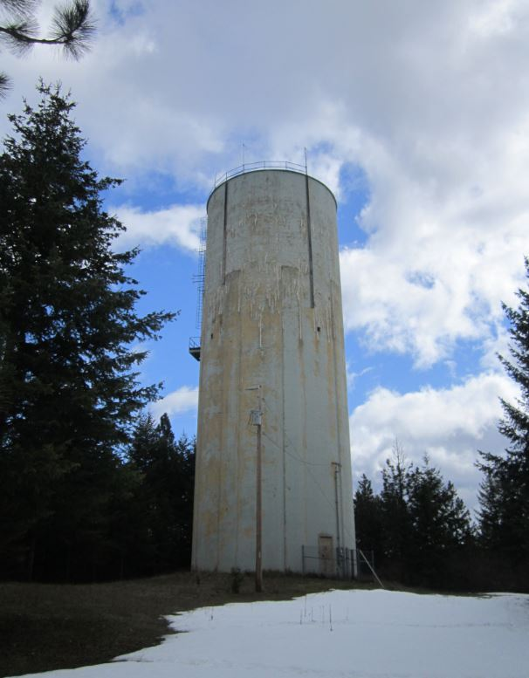

Figure . Farragut Reservoir Tank (225,000 gal)-July 2019

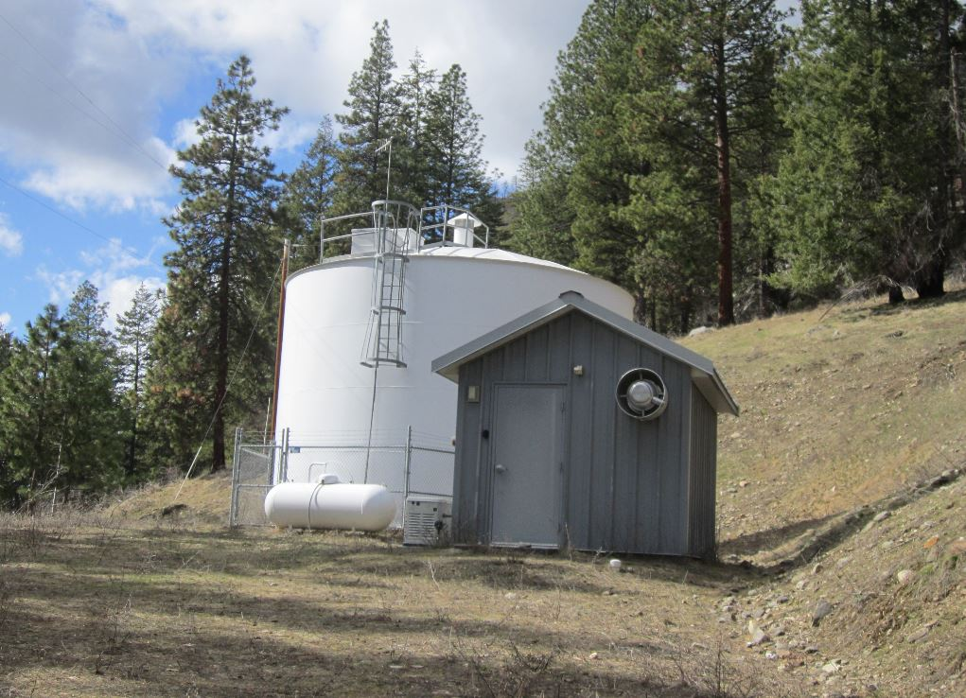

Figure . Pend Oreille Pines Tank (100,000 gal)



Figure . Dromore Reservoir



Figure . Cape Horn Estates Reservoir

**Work to be done on the system:**

Late May of 2020 the community passed a bond issue of $3.4 Million with 1.75% interest on a 30 year loan to refurbish the 1942 vintage system. Projects include refurbishing the 225,000 gallon Farragut storage tank (presently leased from the U.S. Navy) along with installation of a 12-inch water main throughout the town that will increase pressure significantly in the distribution lines. The final phase will concentrate on much needed repair of many distribution system leaks that amount to **about 118,000** gallons of drinking water consistently lost every day.

These changes to the existing system should not affect the water source nor the discharge or pumping rates or the existing delineation area. However, a review of the present delineation area of Well #7 and Well #8 and an updated PCI for each will be conducted at the end of the project.

In the event that any new sources are added (**no need or plans at this time**) to the present ground water supply, the delineation for those new or modified drinking water source sites will be inventoried for potential contaminant sources and the risk will be evaluated. The anticipated pumping rate and existing knowledge of the aquifer will be used to determine which proposed location of a potentially new drinking water source would provide the least risk of contamination. At that time, the town of Bayview can then take appropriate actions to prevent the type of development that may pose a direct threat to the proposed new drinking water source.

# PUBLIC PARTICIPATION

Public participation before and during the development the Bayview Water System Source Water Protection Plan (SWPP) has included the following items.

* Opportunities at council meetings for the public to acquire information and participate in source water protection development and implementation.
* Public notification provided of upcoming opportunities for citizen participation will be listed in the **monthly newsletter and/or monthly water bill.**
* Information can be obtained from the Water System Office (Jessie Roe):

Phone **(208) 683-3948** or e-mail: [**bwsd637@gmail.com**](mailto:bwsd637@gmail.com)

* Robert Kuchenski (Operator) (**208) 683-3949** or e-mail: [**bob@integritywater.net**](mailto:bob@integritywater.net)
* Alternate Water Operator – Bob Hansen (208) 265-4270

Other contact information (Board Members) :

* Calvin Nolan (District Chair) – e-mail: [bullseyenid@yahoo.com](mailto:bullseyenid@yahoo.com)
* Ali Spahn - e-mail: [spahnbwsd@gmail.com](mailto:spahnbwsd@gmail.com)
* Ted Bare – e-mail: [3bareted@gmail.com](mailto:3bareted@gmail.com)
* Larry Leake- e-mail: [larry.m.leake@hotmail.com](mailto:larry.m.leake@hotmail.com)

# REFERENCES

* *DEQ Idaho Department of Environmental Quality (IDEQ)*, 2019. Bayview Water & Sewer, Kootenai County, Idaho PWS ID 1280014 Sanitary Survey Report (3/26/19)
* *DEQ Idaho Department of Environmental Quality (IDEQ)*, 2016 Source Water Assessment Report. (PWS ID 1280014). Boise ID:DEQ. (8/16/16) ***http://www2.deq.idaho.gov/water/swaOnline/***
* DEQ *Idaho Department of Environmental Quality*) *(IDEQ*) 2010. *Title of Report: Sometimes has a Subtitle Too*. Boise, ID: DEQ
* *DEQ Idaho Department of Environmental Quality (IDWQ*), 2000. Protecting Drinking Water Sources in Idaho. Boise, ID: DEQ
* *DEQ Idaho Department of Environmental Quality (IDEQ)* 1999. Idaho Source Water Assessment Plan. Boise, ID: DEQ
* *DEQ Idaho Department of Environmental Quality (IDEQ),* 1997. Idaho Source Water/Wellhead Protection Plan

# RESOURCES

* Idaho Bureau of Homeland Security. <http://www.bhs.idaho.gov>
* Idaho Department of Environmental Quality (DEQ). Source Water Protection in Idaho.

<http://www.deq.idaho.gov/water-quality/source-water/protection/>

* DEQ Source Water Protection in Idaho.

<http://www.deq.idaho.gov/water-quality/source-water/activity-guide/>

* Idaho Department of Environmental Quality. <http://www.deq.idaho.gov>

# GLOSSARY

|  |  |
| --- | --- |
| **Aquifer** | A geologic formation, group of formations, or part of a formation that is saturated and sufficiently permeable to transmit economic quantities of water to wells and springs. |
| **Aquitard** | A low-permeability geologic unit that can store groundwater and also transmit it slowly from one aquifer to another. |
| **AST (aboveground storage tank)** | Aboveground storage tanks |
| **BMPs (best management practices)** | Conservation practices or systems of practices and management measures that (1) reduce water quality degradation caused by nutrients, animal waste, toxics, and sediment, as well as control soil loss; and (2) minimize adverse impacts on surface water, groundwater flow, and circulation patterns and on the biological, chemical, and physical characteristics of wetlands. |
| **Capacity** | The flow rate that a pump is capable of producing.  Also, a water utility’s ability to have resources available to meet the water service needs of its customers. In this context, capacity is the combination of plant- and service-related activities necessary to meet the quantity, quality, peak loads, and other service needs of the various customers or classes of customers served by the utility. |
| **CERCLA** | Comprehensive Environmental Response, Compensation, and Liability Act |
| **Community system** | A public water system serving at least 15 service connections used by year-round residents or regularly serving at least 25 year-round residents. |
| **Contaminant** | Any physical, chemical, biological, or radiological substance or matter in water |
| **Contaminant source inventory** | A record of the activities on a watershed or aquifer recharge area that have a potential to contaminate water |
| **Emergency Response Plan** | A document that details the intended actions of a water utility under specified adverse conditions |
| **Dairy** | Sites included in the primary contaminant source inventory represent those facilities regulated by the Idaho State Department of Agriculture (ISDA) and may range from a few head to several thousand head of milking cows |
| **Deep injection well** | A well discharging under pressure to a deep subsurface stratum. Such a well is often used to dispose of liquid waste streams to a suitable confined poor-water-quality aquifer that is generally considered unusable for other purposes.  Injection wells deeper than 18 feet below land surface are regulated under the Idaho Department of Water Resources and are generally for the disposal of storm water runoff or agricultural field drainage. |
| **Enhanced inventory** | Enhanced inventory locations are potential contaminant source sites added by the water system. These can include new sites not captured during the primary contaminant inventory, or corrected locations for sites not properly located during the primary contaminant inventory. Enhanced inventory sites can also include miscellaneous sites added by the Idaho Department of Environmental Quality (DEQ) during the primary contaminant inventory. |
| **Group I sites** | These are sites that show elevated levels of contaminants and are not within the priority one areas |
| **IDAPA** | Idaho Administrative Procedures Act |
| **Inorganic priority area** | Priority one areas where greater than 25% of the wells/springs show constituents higher than primary standards or other health standards |
| **IOC (inorganic compound)** | An inorganic substance regulated by the U.S. Environmental Protection Agency (EPA) in terms of compliance monitoring for drinking water. Contained on the agency’s list are compounds as diverse as asbestos, nitrate (NO3-), cyanide, and nickel. This abbreviation came into common use in EPA’s Phase V drinking water regulations. An inorganic compound is sometimes called an inorganic chemical. |
| **Leachate** | The liquid that is derived from the leaching of buried refuse in septic systems, sanitary landfills, and dumps by percolating water derived from rain or snowmelt. Leachate contains large numbers of inorganic contaminants, and the total dissolved solids can be very high. |
| **LUST (leaking underground storage tank)** | Potential contaminant source sites associated with leaking underground storage tanks as regulated under RCRA |
| **MCL (maximum contaminant level)** | A value defined under the Safe Drinking Water Act, Section 1401 (3) as the maximum permissible level (concentration) of a contaminant in water delivered to any user of a public water system. Maximum contaminant levels are the legally enforced standards in the United States. |
| **Microbes** | A microscopic organism, either plant or animal, invisible to the naked eye. Examples are algae, bacteria, fungi, protozoa, and viruses. |
| **Nitrate priority area** | Area where greater than 25% of wells and or springs show nitrate values above 5 milligrams per liter |
| **Nonpoint source** | Waste material that enters a water body from overland flow rather than out of a pipe or channel; an unconfined discharge of waste. |
| **NPDES** | National Pollutant Discharge Elimination System |
| **Organic priority areas** | These are any areas where greater than 25% of wells/springs show levels greater than 1% of the primary standard or other health standards |
| **P2** | An acronym for pollution prevention |
| **Perched aquifer** | A small lens of unconfined groundwater separated from an underlying main body of groundwater by an impermeable unsaturated zone |
| **Point source** | A discharge that comes out of the end of a pipe, as opposed to runoff or a discharge from a field or similar source, which is called a nonpoint source. |
| **RCRA** | Resource Conservation and Recovery Act. RCRA gives the U.S. Environmental Protection Agency the authority to control hazardous waste from “cradle-to-grave” |
| **SARA Title III** | Superfund Amendments and Reauthorization Act, Title III: Emergency Planning and Community Right-to-know |
| **Sanitary survey** | An on-site review of a water utility’s water source, facilities, equipment, and operations and maintenance records for the purpose of evaluating the system’s adequacy in producing and distributing safe drinking water. |
| **SOC (synthetic organic compound)** | An organic compound that is commercially made. Some synthetic organic compounds are contaminants in drinking water and are regulated by the U.S. Environmental Protection Agency. Regulated synthetic organic compounds include volatile organic compounds, pesticides, herbicides, polychlorinated biphenyls, selected treatment chemicals (e.g., acrylamide), and polynuclear aromatic hydrocarbons. |
| **TOT (time-of-travel)** | The determination, usually made through modeling, of the time in years for groundwater recharge to travel from a certain field point to the wellhead. |
| **UST** | Underground storage tank |
| **Vadose zone** | The unsaturated portion of the soil column between the land surface and the water table. A better term is **unsaturated zone.** |
| **VOC (volatile organic compound)** | A class of organic compounds that includes gases and volatile liquids. Many volatile organic compounds are used as solvents. A number of these compounds are regulated by the U.S. Environmental Protection Agency. |
| **WLAP (wastewater land application permit)** | Areas where the land application of municipal or industrial wastewater is permitted by DEQ are referred to as WLAP sites |
| **Wellheads** | Drinking water well locations regulated under the Safe Drinking Water Act. Wellheads are not treated as potential contaminant sources. |
| **Zone IA** | Sanitary setback zone designed to prevent microbial contamination within a 100-foot radius of the wellhead. This setback zone is established in the Idaho Rules for Drinking Water Supplies (IDAPA 58.01.08.900.01) and requires that sewer lines, livestock, canals, and streams be 50 feet from the source water/wellhead and that home septic tanks, seepage pits, disposal fields, and privies be 100 feet away. |
| **Zone IB** | The zone within the 3-year time-of-travel for groundwater to reach the wellhead |
| **Zone II** | The zone within the 6-year time-of-travel for groundwater to reach the wellhead |
| **Zone III** | The zone within the 10-year time-of-travel for groundwater to reach the wellhead |



Potential Contaminant Source Inventory

Table . Bayview PCI for Well #7

|  |  |  |  |  |  |  |
| --- | --- | --- | --- | --- | --- | --- |
| **TOT** | **Description of Potential Contaminant Source** | **Potential Contaminant(s)** | **Name** | **Data Scr** | **Updated Date** | **Priority Level L, M, H** |
| 0-3 year | Major And Minor Roads | IOC, VOC, SOC, Microbe | State Hwy 54 | GIS | 8/16/2016 | L |
| 6-10 year | Major And Minor Roads | IOC, VOC, SOC, Microbe | Kinglet Drive is close to well #7 but not in the (0 to 3 year) zone of influence | GIS | 8/16/2016 | L |

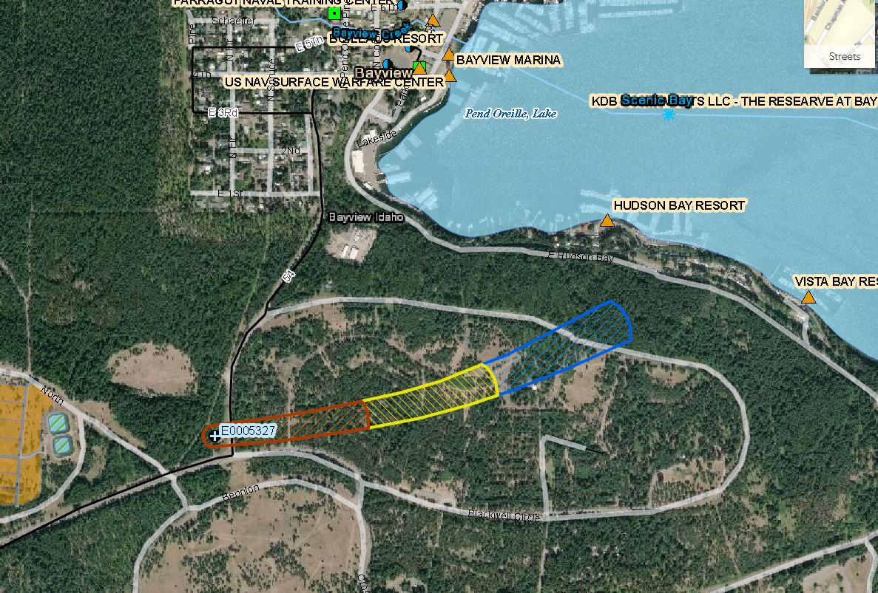

Well #7 Delineation Area

Kinglet Drive

Table . Bayview PCI for Well #8

|  |  |  |  |  |  |  |
| --- | --- | --- | --- | --- | --- | --- |
| **TOT** | **Description of Potential Contaminant Source** | **Potential Contaminant(s)** | **Name** | **Data Scr** | **Updated Date** | **Priority Level L, M, H** |
| 0-3 year | No Major or Minor Roads | No potential contaminants | Close to Kindlet Drive-but not in delineation area | GIS | 8/16/2016 | N/A |
| 6-10 year | No Major or Minor Roads | No potential contaminants | N/A | GIS | 8/16/2016 | N/A |

*Features seen in the dynamic (not static) map are the features that the GIS PCI process captures as potential contaminant sources. Every 3-5 years there is a PCI update, but in the case of these Bayview wells, the PCI didn’t pick up any additional features. As can be seen from the dynamic map below, **no potential contaminant sources intersect with the delineation area for Well #8** in the (0-3), (3-6) or (6-10) year Time of Travel (TOT). (See delineation area below):

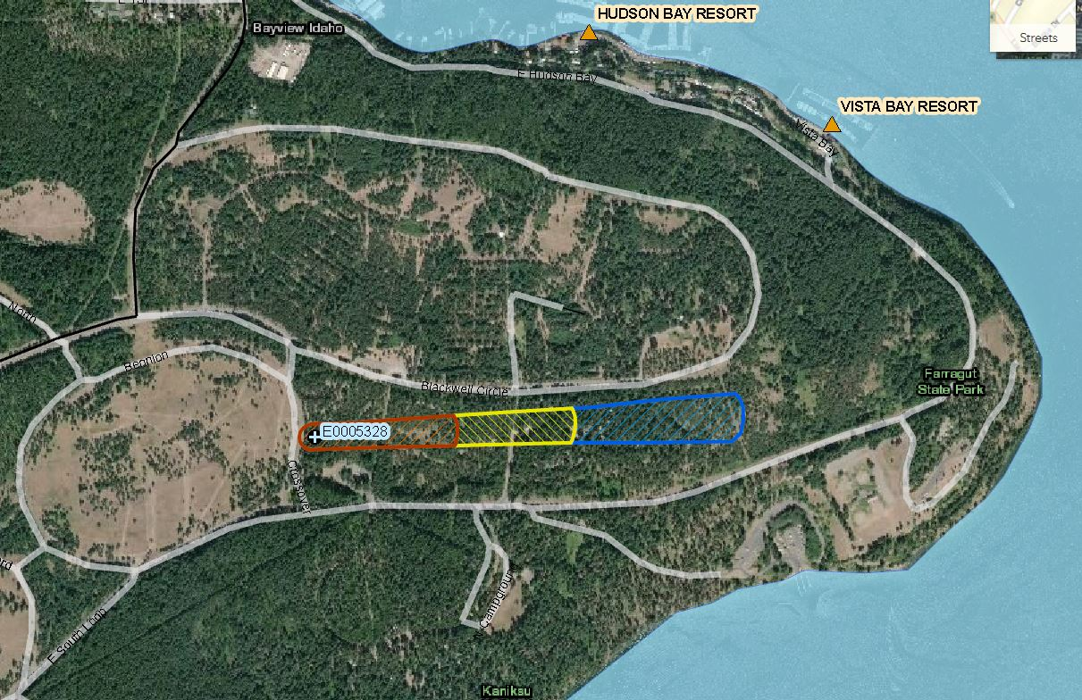

Kinglet Drive

Well #8 Delineation Area

*This page intentionally left blank for correct double-sided printing*



Best Management Practices (BMPs) to Protect Source Water

Literature for Public Awareness and Education

*This page intentionally left blank for correct double-sided printing*

Table . Voluntary Best Management Practices to Protect Source Water

| **POTENTIAL SOURCE** | **RECOMMENDED ACTIVITIES** |
| --- | --- |
| **Auto Repair Shops** | **Non-structural:** The municipality should ensure that the city monitors auto repair shops for compliance with applicable laws. City inspectors should pay particular attention to possible dumping of automotive fluids, paints, and solvents. They should also ensure that these chemicals are not being discharged into wells, septic systems, municipal sewage, or storm sewage systems. |
| **Auto Salvage Yards** | **Non-structural:** Automotive fluids should be properly collected, contained, and disposed of in accordance with applicable laws. Ensure that automotive fluids are not being disposed of down abandoned wells. Require that all abandoned wells be plugged.  **Education/Outreach:** Establish a Public Education Program to inform auto salvage yard operators of their responsibilities in disposing of automotive fluids. |
| **Car Washes** | **Structural:** Wastewater from car washes should be discharged into appropriate sewage facilities or retention ponds. Backflow prevention devices should be installed and should be in good operating condition.  **Non-structural:** Ensure that wastewater from car washes in not being disposed of down abandoned wells. Close down and retrofit any car wash that is not in compliance. |
| **Cemeteries** | **Non-structural:** Existing cemeteries should be developed in a direction away from public water supply wells. New public water supply wells should not be located in close proximity to existing graveyards.  **Monitoring:** Monitor nearby water wells periodically for any contamination. |
| **Chemical Storage and Handling** | **Structural:** Containers should be placed on impermeable surfaces with containment structures.  **Non-structural:** Chemicals should be stored and transported in accordance with applicable laws. Require facilities to be secured from unauthorized access. Prohibit chemical storage near water wells or in 100-year flood plains. Include chemical storage facilities in spill response and contingency planning. |
| **Dry Cleaners** | **Non-structural:** Owners and/or operators of dry cleaners should follow manufacturers’ instructions for the proper operation and maintenance of machines and control devices. Owners and operators should ensure that any onsite chemicals are stored, handled, and disposed of according to state and federal law. The city should verify that these laws are being followed. The local entity should ensure all inventoried owner and operators of dry cleaning facilities maintain a copy of the manufacturers’ specifications or standard operating and maintenance manuals onsite. |
| **Fertilizer and Pesticide Application** | **Structural:** Contour cropping, filter strips, furrow baffles, and other conservation methods are effective tools to minimize fertilizer and pesticide contamination.  **Non-structural:** Fertilizers and pesticides should be applied according to label instructions to minimize leaching and runoff. Applicators should carefully calibrate application equipment.  **Education/Outreach:** Establish a Public Education Program to inform farmers, ranchers and agricultural product applicators of the importance of fertilizing according to soil tests, proper nutrient placement, and timing of fertilizer applications to maximize nutrient use efficiency and minimize the environmental impact on source water. Encourage applicators to seek out better management practices they may implement, and/or programs available to agricultural producers.  **Monitoring:** These contaminants could be monitored to determine the location of high priority areas and determine the effectiveness of the structural best management practices.  **Education/Outreach:** [*http://www.fsa.usda.gov/FSA/stateoffap?mystate=id&area=home&subject=landing&topic=landing*](http://www.fsa.usda.gov/FSA/stateoffap?mystate=id&area=home&subject=landing&topic=landing) |
| **Illegal Dumping** | **Non-structural:** Law enforcement or code enforcement officials should be authorized to patrol source water protection areas for illegal dumping and prosecute violators. Render inaccessible frequent dumping sites and post no dumping signs. Establish a hotline for citizens to report violations. |
| **Industrial Facilities** | **Non-structural:** Industrial facilities should be operated under strict site safety and health plans. These should be on file with the local fire marshal. Ensure that site safety plans and health plans are on file, and that the PWS official is to be contacted in the event of an emergency. |
| **Mining Activities** | **Non-structural:** Mining and other mineral extraction activities should be monitored for violations. Violations should be reported. Include mining operations in spill response and contingency planning. |
| **Municipal Sewage Pipelines** | **Structural:** Faulty lines should be repaired or replaced as soon as possible. New methods exist which allow pipelines to be repaired without excavation or unreasonable expense.  **Monitoring:** Municipal sewage pipelines should be tested regularly to ensure that they do not allow for infiltration/exfiltration, especially those in close proximity to drinking water supplies. |
| **Municipal Storm Water Drainage** | **Structural:** Municipal sewers and drainage canals should be properly maintained to eliminate clogging and overflow during storm water events. Municipal Storm Water Drainage System should be properly sited, constructed, and operated to ensure a safe means of waste disposal.  **Non-structural:** Ensure existing systems with dry wells, and/or utility disposal wells meet Underground Injection Control rules and regulations. Identify and participate in designated local Municipal Solid Waste Planning Area meetings. The local community should coordinate with the local Council of Government to participate in, and/or development of, the area Municipal Solid Waste Plan, and to establish Solid Waste Assistance Partnerships provided through the state. |
| **Oil and Gas Activities** | **Non-structural:** PWS representatives should check to see the oil & gas company has a spill response plan in place and is aware they are in a drinking water protection area. Include these activities in spill response and contingency planning.  **Monitoring:** Oil and gas activities should be closely monitored for leaks or spills. Violations should be reported to the DEQ.  **Rules**: IDAPA |
| **Particulate Airborne Sources** | **Non-structural:** Airborne sources must be in compliance with applicable laws. Require that air permitted industries immediately notify water system official of any potentially threatening discharge. |
| **Radium and Radon Gas** | Radium/radon gas removing technology should be installed if determined to be necessary for treatment. Effective technologies, ranging from simple aeration to more expensive methods, exist to safely remove radium/radon gas from water. |
| **Septic Systems** | **Structural:** Septic systems should be constructed, maintained and operated in accordance with applicable laws. Inactive systems should be properly closed and failing systems should be renovated or removed and placed on a sewage treatment plant.  **Non-structural:** Contact septic system operators and advise them of their responsibilities in maintaining their systems. Provide them with a telephone number in case of emergencies. Require establishments to connect and close their systems should municipal sewage service become available.  **Education/Outreach:** Provide and disseminate information on the proper maintenance of septic systems.  **Rules:** IDAPA 58.01.03 et. seq. Individual/Subsurface Sewage Disposal Rules.  [*http://www.deq.idaho.gov/water-quality/wastewater/septic-systems.aspx*](http://www.deq.idaho.gov/water-quality/wastewater/septic-systems.aspx)  [*http://www.panhandlehealthdistrict.org/environmental-health/septic*](http://www.panhandlehealthdistrict.org/environmental-health/septic) |
| **Service Station Disposal Wells** | **Structural:** Remediate. Service station disposal wells are illegal, and must be properly closed. All disposal activities should cease immediately. **These wells are one of the most serious threats to groundwater quality!**  **Non-structural:** The DEQ should be notified. Reinspect service station disposal wells to ensure that all disposal activities have ceased. Should any continued disposal activity be identified, order the operator to cease such activity and contact the DEQ for guidance and assistance in taking corrective actions.  **Education/Outreach:** Disseminate information about this environmentally damaging practice.  **Monitoring:** Nearby water wells may be sampled to determine the scope of any contamination from prosecute violators. |
| **Shallow Injection Wells** | **Non-structural:** Shallow injection wells require authorization from the IDWR. Ensure a letter of authorization has been issued by the IDWR for each shallow injection well, and that all injection activities are being properly implemented. Unauthorized injection activities should cease immediately. Prosecute violators and contact the DEQ for assistance.  **Education/Outreach:** Disseminate information about this environmentally damaging practice to involved parties.  **Rules:** IDAPA 37.03.03 Rules for the Construction and Uses of Injection Wells.  IDAPA 42.39.01 Waste Disposal and Injection Wells.  <http://www/legislature.idaho.gov/idstat/Title42/T42CH39.htm> |
| **Superfund Sites** | **Non-structural:** Superfund sites should be remediated as soon as possible. Because the prompt disposition of Superfund sites is rare due to legal and financial complications, new wells should not be developed such that any existing Superfund site would be inside a source water protection area. Include Superfund site in spill response and contingency planning. |
| **Surface Waters** | Public water supply and domestic wells should be properly cased and sealed to guard against inundation. Infiltration of surface waters or runoff should be monitored. Ensure that public water supply well casing extends to 2 feet above the 100-year flood level. Restrict or prohibit development of new wells and storage of hazardous materials in 100-year floodplains. |
| **Underground Pipelines** | **Structural:** Pipeline breaks should be repaired immediately by the pipeline company.  **Non-structural:** PWS representatives should check to see the pipeline company has a spill response plan in place and is aware they are in a drinking water protection area. Include underground pipelines in spill response and contingency planning and know the chemicals in the line.  **Monitoring:** Underground pipelines should be closely monitored for leaks. |
| **Underground Storage Tanks** | **Structural:** Leaking tanks should be removed and the sites should be remediated immediately.  **Education/Outreach:** Underground storage tanks must be registered with the IDWR’s Underground Storage Tank (UST) Program. Require that underground storage tank operators immediately notify water system official in the event of leaks. Include PWS operators in spill response and contingency planning. |
| **Waste Oil Dumping** | **Structural:** Provide a waste oil collection facility.  **Non-structural:** Establish a public education program to encourage citizens to recycle used oil at service stations or other collection centers. |
| **Water Wells** | **Structural:** Water wells should be constructed in compliance with state’s minimum requirements and reconstructed if necessary.  **Non-structural:** Inspect domestic wells to ensure that they are properly constructed. Develop protection areas around wellheads and erect signs designating the protection area.  **Education/Outreach:** Establish a Public Education Program to inform landowners of the hazards of abandoned wells and their responsibilities in plugging them.  **Rule:** IDAPA 37.03.09 Well Construction Standards.  <http://www.idwr.idaho.gov/WaterManagement/WellInformation/>  <http://healthandwelfare.idaho.gov/Health/EnvironmentalHealth/WellWater/tabid/1128/Default.aspx>  <http://www.privatewellclass.org/> |



Susceptibility Scores

*This page intentionally left blank for correct double-sided printing*

**Summary susceptibility scores for potential contamination for the two wells:**

Summary susceptibility scores are specific to a particular potential contaminant or category of contaminants. Therefore, high susceptibility to one potential contaminant does not mean that the water system is at the same risk for all other potential contaminants.

Each of the factors receives a score of high, medium, or low to reflect how susceptible it is to allowing contamination of the source water. Note that deriving susceptibility scores is a qualitative, screening-level step that, in many cases, uses generalized assumptions and best professional judgment. Once completed, susceptibility scores are updated upon request by the public water system.

Potential contaminant inventory (PCI), land use scores and final susceptibility scores consist of four individual scores, one for each of four categories of contaminants:

* Inorganic chemicals (IOC)
* Volatile organic chemicals (VOC)
* Synthetic organic chemicals (SOC)
* Microbial contaminants

High susceptibility to one potential contaminant does not mean that the water system is at the same risk for all other potential contaminants.

**H** = High Susceptibility**, M** = Moderate Susceptibility, **L** = Low Susceptibility. System Construction refers to the well, spring, or surface water intake.

*Susceptibility Scores are summarized on the following page…..

**PWS Name:** ID1280014 BAYVIEW WATER AND SEWER DIST  
**Source Name:** **WELL 7**

| **TOT \*** | **Description of Potential Contaminant Source 1, 4** | **Potential Contaminant(s)** | **Name** | **Data Source 2** | **Updated Date 3** |
| --- | --- | --- | --- | --- | --- |
| 0-3 year | Major And Minor Roads | IOC, VOC, SOC, Microbe | State Hwy 54 | GIS | 8/16/2016 |
| 6-10 year | Major And Minor Roads | IOC, VOC, SOC, Microbe | Kinglet Drive & Blackwell Circle Drive | GIS | 8/16/2016 |

| Susceptibility Scores for BAYVIEW WATER AND SEWER DIST (PWS# ID1280014) **WELL 7** E0005327 | | | | | | | | | |
| --- | --- | --- | --- | --- | --- | --- | --- | --- | --- |
| [System Construction](http://www2.deq.idaho.gov/water/swaOnline/WellSusceptibilityScoringResults?PwsId=ID1280014&SourceTagNumber=E0005327) | [Potential Contaminant Inventory / Land Use](http://www2.deq.idaho.gov/water/swaOnline/WellSusceptibilityScoringResults?PwsId=ID1280014&SourceTagNumber=E0005327) | | | | [Hydrologic Sensitivity](http://www2.deq.idaho.gov/water/swaOnline/WellSusceptibilityScoringResults?PwsId=ID1280014&SourceTagNumber=E0005327) | Final Susceptibility Ranking | | | |
| [IOC](http://www2.deq.idaho.gov/water/swaOnline/SusceptibilitySummaryWells?PwsId=ID1280014&SourceTagNumber=E0005327) | [VOC](http://www2.deq.idaho.gov/water/swaOnline/SusceptibilitySummaryWells?PwsId=ID1280014&SourceTagNumber=E0005327) | [SOC](http://www2.deq.idaho.gov/water/swaOnline/SusceptibilitySummaryWells?PwsId=ID1280014&SourceTagNumber=E0005327) | Microbials | [IOC](http://www2.deq.idaho.gov/water/swaOnline/SusceptibilitySummaryWells?PwsId=ID1280014&SourceTagNumber=E0005327) | [VOC](http://www2.deq.idaho.gov/water/swaOnline/SusceptibilitySummaryWells?PwsId=ID1280014&SourceTagNumber=E0005327) | [SOC](http://www2.deq.idaho.gov/water/swaOnline/SusceptibilitySummaryWells?PwsId=ID1280014&SourceTagNumber=E0005327) | Microbials |
| M | L | L | L | L | H | M | M | M | M |
| H = High Susceptibility, M = Moderate Susceptibility, L = Low Susceptibility. System Construction refers to the well, spring, or surface water intake. | | | | | | | | | |

| Susceptibility Scores for BAYVIEW WATER &Hi SEWER DIST (PWS# ID1280014) **WELL 8** E0005328 (Using the same Hydrologic Sensitivity as Well #7 and assuming the same effects from roads) | | | | | | | | | |
| --- | --- | --- | --- | --- | --- | --- | --- | --- | --- |
| [System Construction](http://www2.deq.idaho.gov/water/swaOnline/WellSusceptibilityScoringResults?PwsId=ID1280014&SourceTagNumber=E0005328) | [Potential Contaminant Inventory / Land Use](http://www2.deq.idaho.gov/water/swaOnline/WellSusceptibilityScoringResults?PwsId=ID1280014&SourceTagNumber=E0005328) | | | | [Hydrologic Sensitivity](http://www2.deq.idaho.gov/water/swaOnline/WellSusceptibilityScoringResults?PwsId=ID1280014&SourceTagNumber=E0005328) | Final Susceptibility Ranking | | | |
| [IOC](http://www2.deq.idaho.gov/water/swaOnline/SusceptibilitySummaryWells?PwsId=ID1280014&SourceTagNumber=E0005328) | [VOC](http://www2.deq.idaho.gov/water/swaOnline/SusceptibilitySummaryWells?PwsId=ID1280014&SourceTagNumber=E0005328) | [SOC](http://www2.deq.idaho.gov/water/swaOnline/SusceptibilitySummaryWells?PwsId=ID1280014&SourceTagNumber=E0005328) | Microbials | [IOC](http://www2.deq.idaho.gov/water/swaOnline/SusceptibilitySummaryWells?PwsId=ID1280014&SourceTagNumber=E0005328) | [VOC](http://www2.deq.idaho.gov/water/swaOnline/SusceptibilitySummaryWells?PwsId=ID1280014&SourceTagNumber=E0005328) | [SOC](http://www2.deq.idaho.gov/water/swaOnline/SusceptibilitySummaryWells?PwsId=ID1280014&SourceTagNumber=E0005328) | Microbials |
| M | L | L | L | L | **H** | M | M | M | M |
| H = High Susceptibility, M = Moderate Susceptibility, L = Low Susceptibility. System Construction refers to the well, spring, or surface water intake. | | | | | | | | | |

**\*If an Auto High Score appeared:**

Four situations cause automatic assignment of a high susceptibility score: (1) any detection of a VOC or SOC, (2) detection of an IOC at a concentration greater than the drinking water maximum contaminant level (MCL) set by EPA, (3) a confirmed microbial detection at the drinking water source, or (4) the presence of potential contaminant sources within 50 feet of a well. Additionally, ground water sources designated as under the direct influence of surface water (GWUDI) automatically rank high for microbial contaminants due to the inherent nature of surface water bodies as wildlife habitat and residence for various microorganisms. Any of the first three situations will trigger an auto-high score because a pathway for contamination already exists. Note that MCLs, detections, and potential contaminants can change over time and are not automatically updated in the score.

System Construction Score:

The first of the three factors scored in a source water assessment is the **system construction**. System construction refers to the construction of the well that serves as the drinking water source. The construction of a well directly affects its ability to protect the aquifer from contaminants. System construction scores are lower when information shows that the design and integrity of the well can help prevent potential contaminants from reaching the aquifer. The system construction score depends on these five components:

1. Compliance with all [current construction standards](http://adminrules.idaho.gov/rules/2012/58/0108.pdf) for water system wells.
2. Condition of the wellhead and surface seal.
3. Placement of the well casing and annular seal into or through at least one continuous low permeability geologic unit of substantial thickness (≥10 feet) reduces the risk of contamination to the aquifer. (Permeability is the ability of a porous medium, such as rock, sediment, and soil, to transmit fluids under a hydraulic gradient; it is a measure of the relative ease of fluid flow under unequal pressure.)
4. Production of water from more than 100-feet below static water level. (Static water level refers to the level of water in a well under normal, no-pumping conditions.) Water drawn from deeper portions of an aquifer is typically buffered from most potential contaminants introduced at the land surface.
5. Location of the well outside of a 100-year floodplain. (A floodplain is flat or nearly flat land along a river or stream or in a tidal area that is covered by water during a flood. The 100-year floodplain is the area likely to be inundated during a flood with a 1% chance of being equaled or exceeded in any given year. DEQ uses data from the Federal Emergency Management Agency to determine the 100-year floodplain for any given area.) Locating wells outside a floodplain can help prevent direct contact between the wellhead and storm, flood, or irrigation water.

Idaho Department of Water Resources’ rules regulate well construction (“[Well Construction Standards Rules](http://adminrules.idaho.gov/rules/current/37/0309.pdf)” [IDAPA 37.03.09]). These rules require all public water systems to also follow DEQ’s well construction standards (“[Idaho Rules for Public Drinking Water Systems](http://adminrules.idaho.gov/rules/2012/58/0108.pdf)” [IDAPA 58.01.08.510]). DEQ standards include screening requirements, depth of annular seal, use of a down-turned casing vent, and casing thickness, height, and depth. Current construction standards for public water system wells can be more stringent than standards in effect when a well was constructed, so your system construction score may be higher due to not meeting current well construction standards.

**Hydrologic Sensitivity Score:**

The high reading for **Hydrologic Sensitivity** is a natural phenomenon that cannot be changed.

Hydrologic sensitivity considers how easily or quickly water moves through the subsurface of the earth. A well’s hydrologic sensitivity score depends on the following:

1. Composition of surface soil. Soil drainage classes (defined in soil surveys published by the NRCS in 1998), ranging from poorly drained to moderately drained, such as silt and clay, are deemed more protective of ground water than moderately to well drained soils, such as sand and gravel, which drain faster.
2. Material in the vadose zone (the zone between the land surface and first encountered water). Vadose zone materials comprised of gravel or fractured rock provides less protection from contamination than finer-grained sedimentary materials.
3. Depth at which ground water is first encountered. All other factors being equal, a greater depth to ground water provides greater opportunity for the attenuation of potential contaminants through adsorption and other mechanisms.
4. Presence of a low permeable unit (a layer of rock or sediment that does not transmit water easily, thus protecting the aquifer from contamination). For susceptibility scoring, DEQ considers a low permeable unit to be present if there is >50 feet of cumulative thickness of silt or clay-rich geologic materials, or fine grain sedimentary interbeds within basalt settings above the bottom of the annular seal to be protective of the aquifer.

Potential Contaminant Inventory/Land Use:

The other factor scored in a source water assessment for surface water sources is the **Potential Contaminant Inventory (PCI**) / **land use**. A potential contaminant is defined as any facility or activity that meets these criteria:

Stores, uses, or produces, as a product or by-product, the [**contaminants**](http://water.epa.gov/drink/contaminants/index.cfm) regulated under the federal Safe Drinking Water Act.

Has a potential of releasing the contaminants at levels that could potentially harm drinking water sources.

As part of each source water assessment, DEQ conducts an inventory of potential sources of contamination. The goal of the inventory is to locate and describe facilities, land uses, and environmental conditions that are potential sources of surface water contamination.

Farragut recreational areas add a significant source of contamination to the ground water sources.

When agriculture is the predominant land use within the delineation area, the likelihood of agricultural chemicals, such as fertilizers and pesticides, running off into the surface water body may increase.

This results in more points assessed for the IOC and SOC categories. Depending on the percentage of agricultural land in the delineated area, PCI / land use susceptibility scores may be influenced by this increase.

*This page intentionally left blank for correct double-sided printing*



Overview of Potential Contaminant Sources

*This page intentionally left blank for correct double-sided printing*

Table 6 provides an overview of potential contaminant sources and the contaminants that may be associated with each source. These sources represent many of the businesses, industries, operations, land uses, and environmental conditions that handle, generate, store, apply, dispose of, or provide a pathway for the contaminants of concern. The sources are separated into four categories:

1) Commercial/Industrial

2) Agricultural/Rural

3) Residential/ Municipal and

4) Miscellaneous

These sources can apply to either groundwater or surface water, and many can apply to both ground and surface water. Where a potential contaminant source generally applies to only groundwater or surface water, it is noted within Table 6.

Table . Overview of Potential Contaminant Sources

| **Source** | | **Potential Contaminants 1,2,3** |
| --- | --- | --- |
| **Commercial/Industrial** | | |
| Automobile | Body Shops/ Repair Shops | Waste oils, gasoline and diesel fuels; solvents, acids, paints, automotive wastes4, miscellaneous cutting oils |
| Car Washes | Soaps, detergents, waxes, miscellaneous chemicals, hydrocarbons |
| Gas Stations | Petroleum fuels, oil, solvents, miscellaneous wastes. |
| Boat Services/Repair/Refinishing | | Gasoline and diesel fuels, oil, septage from boat waste disposal area, wood preservative and treatment chemicals, paints, waxes, varnishes, automotive wastes.4 |
| Cement/Concrete Plants | | Diesel fuel, solvents, oils, miscellaneous wastes. |
| Chemical/Petroleum Processing/Storage | | Hazardous chemicals, solvents, hydrocarbons, heavy metals. |
| Dry Cleaners | | Solvents (tetrachloroethylene, petroleum solvents), spotting chemicals (trichloroethane, methyl chloroform, ammonia, peroxides, hydrochloric acid & amyl acetate). |
| Electrical/Electronic Manufacturing | | Cyanides, metal sludge, caustic (chromic acid), solvents, oils, alkalis, acids, paints and paint sludge, PCBs. |
| Fleet/Trucking/Bus Terminals | | Waste oil, solvents, gasoline and diesel fuel from vehicles and storage tanks, fuel oil, other automotive wastes.4 |
| Food Processing | | Nitrates, salts, phosphorous, miscellaneous food wastes, chlorine, ammonia, ethylene glycol. |
| Furniture Repair/Manufacturing | | Paints, solvents, degreasing and solvent recovery sludge, lacquers, sealants. |
| Hardware/Lumber/Parts Stores | | Hazardous chemical products in inventories, heating oil and fork lift fuel from storage tanks, wood-staining and treating products such as creosote, paints, thinners, lacquers, varnishes. |
| Home Manufacturing | | Solvents, paints, glues and other adhesives, waste insulation, lacquers, tars, sealants, epoxy wastes, miscellaneous chemical wastes. |
| Junk/Scrap/Salvage Yards | | Automotive wastes4, PCB contaminated wastes, any wastes from businesses5 and households6, oils, lead. |
| Machine Shops | | Solvents, metals, miscellaneous organics, sludge, oily metal shavings, lubricant and cutting oils, degreasers (tetrachloroethylene), metal marking fluids, mold-release agents. |
| Metal Plating/Finishing/Fabricating | | Sodium and hydrogen cyanide, metallic salts, hydrochloric acid, sulfuric acid, chromic acid, boric acid, paint wastes, heavy metals, plating wastes, oils, solvents. |
| Mines/Gravel Pits | | Mine spills or tailings that often contain metals, acids, highly corrosive mineralized waters, metal sulfides, metals, acids, minerals sulfides, other hazardous and nonhazardous chemicals, petroleum products and fuels. |
| Photo Processing/Printing | | Biosludges, silver sludge, cyanides, miscellaneous sludge, solvents, inks, dyes, oils, photo-chemicals. |
| Plastics/Synthetics Producers | | Solvents, oils, miscellaneous organic and inorganics. (phenols, resins), paint wastes, cyanides, acids, alkalis, wastewater treatment sludge, cellulose esters, surfactant, glycols, phenols, peroxides, etc. |
| Research/University/Hospital Laboratories | | X-ray developers and fixers7, infectious wastes, radiological wastes, biological wastes, disinfectants, asbestos, beryllium, solvents, infectious materials, drugs, disinfectants, miscellaneous chemicals. |
| Wood Preserving/Treating | | Wood preservatives: creosote, pentachlorophenol, arsenic, heavy metals. |
| Wood/Pulp/Paper Processing and Mills | | Metals, acids, sulfides, other hazardous and nonhazardous chemicals, organic sludge, sodium hydroxide, chlorine, hypochlorite, chlorine dioxide, hydrogen peroxide, methanol, paint sludges, solvents, creosote, coating and gluing wastes. |

|  |  |
| --- | --- |
| **Agricultural/Rural** | |
| Livestock Auction Lots/Boarding Stables | Nitrates, phosphorous, bacteria, and viruses, total dissolved solids. |
| Confined Animal Feeding Operations  Slaughter House and Butcher Facilities | Nitrates, phosphorous, chloride, chemical sprays and dips for controlling insect, bacteria and viruses, total dissolved solids. |
| Farm Machinery Repair | Automotive wastes4, solvents, fuel. |
| Crops - Irrigated and Non-irrigated | Pesticides8, nitrate & phosphorous (from fertilizers), salts, sediment (from runoff). |
| Wastewater/Sludge/Manure Land Application or Disposal Locations | Nitrates, metals, salts, bacteria and viruses. |
| Lagoons/Liquid Wastes | Nitrates, livestock sewage wastes, salts, bacteria. |
| Pesticide/Fertilizer/Petroleum Storage & Transfer Areas | Pesticides8 , nitrate, phosphorous, petroleum residue. |
| **Residential/Municipal** | |
| Airports (Maintenance/Fueling Areas) | Jet fuels, deicers, diesel fuel, chlorinated solvents, automotive wastes4, heating oil, building wastes.5 |
| Camp Grounds/RV Parks, Marinas | Septage, gasoline, diesel fuel from boats, pesticides8, household hazardous wastes from recreational vehicles (RVs).6 |
| Drinking Water Treatment plants | Treatment chemicals. |
| Golf Courses | Pesticides8, nitrate, phosphorous, arsenic. |
| Landfills/Dumps | Organic and inorganic chemical contaminants; waste from households6 and businesses5, nitrates, oils, metals, solvents. |
| Motor Pools | Automotive wastes4: solvents, waste oils, fuel storage. |
| Railroad Yards/Maintenance/Fueling Areas | Diesel fuel; herbicides for rights-of-way8, creosote from preserving wood ties, solvents, paints, waste oils. |
| School Maintenance Facilities | Machinery/vehicle serving wastes, gasoline.4 |
| Septic Systems (large community systems or 10 single systems on 40 acres) | Bacteria, viruses, nitrates, salts, dissolved solids, improperly disposed of household or business wastes5,6,9 |
| Utility Stations/Maintenance Areas | PCBs from transformers and capacitors, oils, solvents, sludge, acid solution, metal plating solutions (chromium, nickel, cadmium). |
| Waste Transfer/Recycling Stations | Residential and commercial solid waste residues |
| Wastewater Effluent to Surface Waters (primarily surface water concern) | Municipal wastewater, sludge10, treatment chemicals11, nitrates, heavy metals, bacteria, nonhazardous wastes |
| **Miscellaneous** | |
| Above Ground Storage Tanks | Diesel, gasoline, other chemicals. |
| Construction/Demolition Areas (Plumbing, Heating, and Air Conditioning, Painting, Carpentry, Flooring, Roofing and Sheet Metal | Solvents, asbestos, paints, glues and other adhesives, wastes insulation, lacquers, tars, sealants, epoxy waste, miscellaneous chemical wastes, explosives, sediment. |
| Historic Gas Stations | Diesel fuel, gasoline, kerosene. |
| Historic Waste Dumps/Landfills | Leachate, organic and inorganic chemicals, waste from households6, and businesses5, nitrates, oils, heavy metals, solvents. |
| Injection Wells/Dry Wells/Sumps (primarily ground water concern) | Storm water runoff, used oils, antifreeze, gasoline, solvents, other petroleum products, pesticides8, and other chemical substances. |
| Storm Water Drainage to Surface Waters (primarily surface water concern) | Storm water runoff, oils, antifreeze, metals, sediment, and pesticides, and a wide variety of other substances. |
| Military Installations | Wide variety of hazardous and nonhazardous wastes depending on the nature of the facility, diesel fuels, jet fuels, solvents, paints, waste oils, heavy metals, radioactive wastes, explosives. |
| Surface Water - Stream/Lakes/Rivers/Recharge Sites | Ground Water: bacteria and viruses, cryptosporidium  Surface Water: nitrates, pesticides, sediment from Ag. return drains. |
| Transportation Corridors | Herbicides in highway right-of-way8, road salt (sodium and calcium chloride), road salt anti-corrosives (phosphate and sodium ferrocyanide), automotive wastes4, nitrate or phosphorous from fertilizer use. |
| Forest Roads /Logging  (primarily surface water concern) | Sediment, fuel spills. |
| Landslides/Burn Areas  (primarily surface water concern) | Sediment |
| Underground Storage Tanks | Diesel, gasoline, heating oil, other chemical and petroleum products. |
| Unsealed or Abandoned Wells, and Test Holes (primarily GW concern) | Storm water runoff, solvents, nitrates, septic tanks, hydrocarbons, and a wide variety of other substances. |

Summary of Potential Contaminants:

1) In general, surface or ground water contamination stems from the misuse and improper disposal of liquid and solid wastes; the illegal dumping or abandonment of household, commercial, or industrial chemicals; the accidental spilling of chemicals from trucks, railways, aircraft, handling facilities, and storage tanks; or the improper siting, design, construction, operation, or maintenance of agricultural, residential, municipal, commercial, and industrial drinking water wells and liquid and solid waste disposal facilities. Contaminants also can stem from atmospheric pollutants, such as airborne sulfur and nitrogen compounds, which are created by smoke, flue dust, aerosols, and automobile emissions, fall as acid rain, and percolate through the soil. When the sources list in these tables are used and managed properly, water contamination is not likely to occur.

2) Contaminants can reach ground water from activities occurring on the land surface, such as industrial waste storage; from sources below the land surface but above the water table, such as septic systems; from structures beneath the water table, such as wells; or from contaminated recharge water.

3) This table lists the most common potential contaminants, but not all-potential contaminants. For example, it is not possible to list all potential contaminants contained in storm water runoff or from military installations.

4) Automobile wastes can include gasoline; antifreeze; automatic transmission fluid; battery acid; engine and radiator flushes; engine and metal degreasers; hydraulic (brake) fluid & oil.

5) Common wastes from public and commercial buildings include automotive wastes; and residues from cleaning products that may contain chemicals such a xylenols, glycol esters, isopropanol, 1, 1, 1, -trichloroethane, sulfonates, chlorinated phenols, and cresol.

6) Households wastes include common household products that can contain a wide variety of toxic or hazardous components.

7) X-ray developers and fixers may contain reclaimable silver, glutaldehyde, hydroquinone, potassium bromide, sodium sulfite, sodium carbonate, thiosulfates, and Alum.

8) Pesticides include herbicides, insecticides, rodenticides, and fungicide. EPA has registered approximately 50,000 different pesticide products for use in the United States. Many are highly toxic and quite mobile in the subsurface.

9) Septic tank/cesspool cleaners include synthetic organic chemicals such as 1, 1, 1,-trichloroethane, tetrachloroethylene, carbon tetrachlorine, and methylene chloride.

10) Municipal wastewater treatment sludge can contain organic matter, nitrates; inorganic salts; heavy metals; coliform and noncoliform bacteria; and viruses.

11) Municipal wastewater treatment chemicals include calcium oxide; alum; activated alum; polymers; ion exchange resins; sodium hydroxide; chlorine; ozone; and corrosion inhibitors.

**Source: Adapted from EPA (1993).**



Source Water Protection – Certification Checklist

*This page intentionally left blank for correct double-sided printing*

Source Water Protection Plan - Certification Checklist

Public Water System Name: **City of Bayview, Idaho (PWS ID1280014)**

**Local Contact:**

Date Returned to Water System: ________________________________

Source Water Protection Plan Approved _____ Disapproved _____

Idaho Source Water Protection Plan guidance - Protecting Drinking Water Sources in Idaho, August 2000 Pg. 28 of the document states "If a plan is found to satisfy all eight elements, then the community will be recognized by DEQ as having a "State Certified Plan". Additionally, supporting information describing each of the required elements is referenced as well.

**Required Elements of Certified Source Water Protection Plan Element Addressed**

**Element 1** Description of Planning Team Participant Roles and **Yes No**

Duties (Reference *Step 1:* Formation *of a Community*

*Planning Team*)

**Element 2** Delineation of the Source Water Protection Area **Yes No**

(Reference *Step 2: Delineation of the Land Area to be*

*Protected*)

**Element 3** An Inventory of Potential Sources of Contamination **Yes No**

(Reference *Step 3: Identification of Potential Contaminant*

*Sources*)

**Element 4** Management Tools and Protection Measures that will **Yes No**

be Pursued to Manage Potential Sources of Contamination

(Reference *Step 4: Development and Implementation of*

*a Management Plan for Source Water Protection Area*)

**Element 5** A Contingency Plan (Reference *Step 5a: Development of* **Yes No**

*an Emergency Response Plan*)

**Element 6** A Protection Strategy for New Wells or Intakes (Reference **Yes No**

*5b: Planning for Future Drinking Water Sources*)

**Element 7** A Public Participation and Education component **Yes No**

**Element 8** An Implementation Strategy (**what will be done**, **when** **Yes No**

**will it be done**, and **by whom**)

If a plan is found to satisfy all eight elements, then the community will be recognized by DEQ as having a "State Certified Plan". This certification will cover a five year period, after which recertification can be pursued by the community. Recertification will include an evaluation of the community's success in implementing source water protection as a measure of the community's strategy. (**Element 8**).

|  |  |  |
| --- | --- | --- |
| Reviewers | Agency/Affiliation | Comments |
|  |  |  |
|  |  |  |
|  |  |  |

1. The term “Source Water Protection” is the same as Wellhead Protection for ground water sources of drinking water and Drinking Water Protection for ground water and surface water sources. The term “Source Water Protection” will be used throughout this Plan and is synonymous with Drinking Water/Wellhead Protection