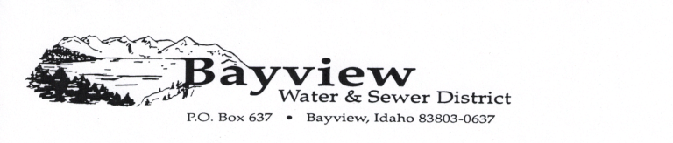
Incident Report

On August 31, 2017, an apparent act of vandalism occurred at the Bayview Water and Sewer Land Application Site.
A sprinkler head was broken off which allowed a spill of approximately 100,000 gallon of treated sewage waste-water to flow onto the field. This waste-water is typically sprayed through these sprinkler heads onto the ground.
There is no hazard to humans or animals as a result of this spill and repairs have been made.
Bayview Water and Sewer has reported the incident to the Kootenai County Sheriff’s Department. Trespassing and vandalism charges will be filed. Violators will be prosecuted to the full extent of the law.

Richard Doney,
Chair, Bayview Water and Sewer

